CS 531 Web Development Technologies

ASSIGNMENT 2

REPORT

By

Ravi Sai Sashank #258317

Divya Pavan Sai Alamuri #255562

**A. HTML Forms:**

The following are the HTML5 Web Page Elements:

1**. VIDEO TAG**: The video tag is used for inserting the required videos into our Web Page.

<video>…. </video>. The following is the code for the video tag.

CODE:

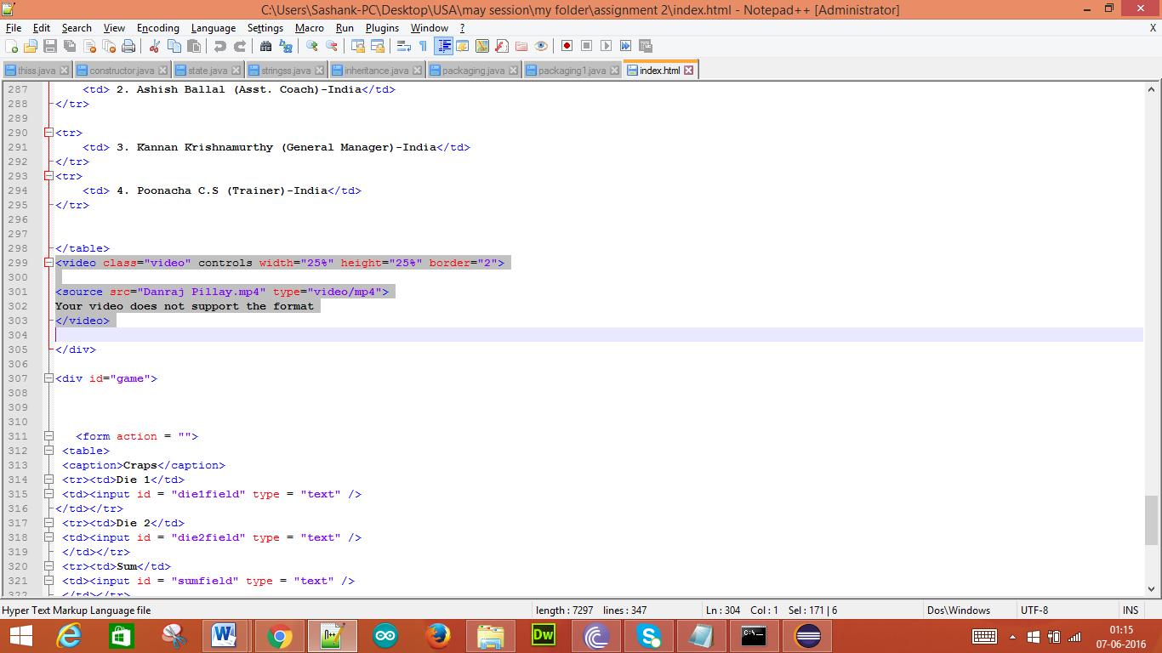

This is the video which has been inserted into the Web Page

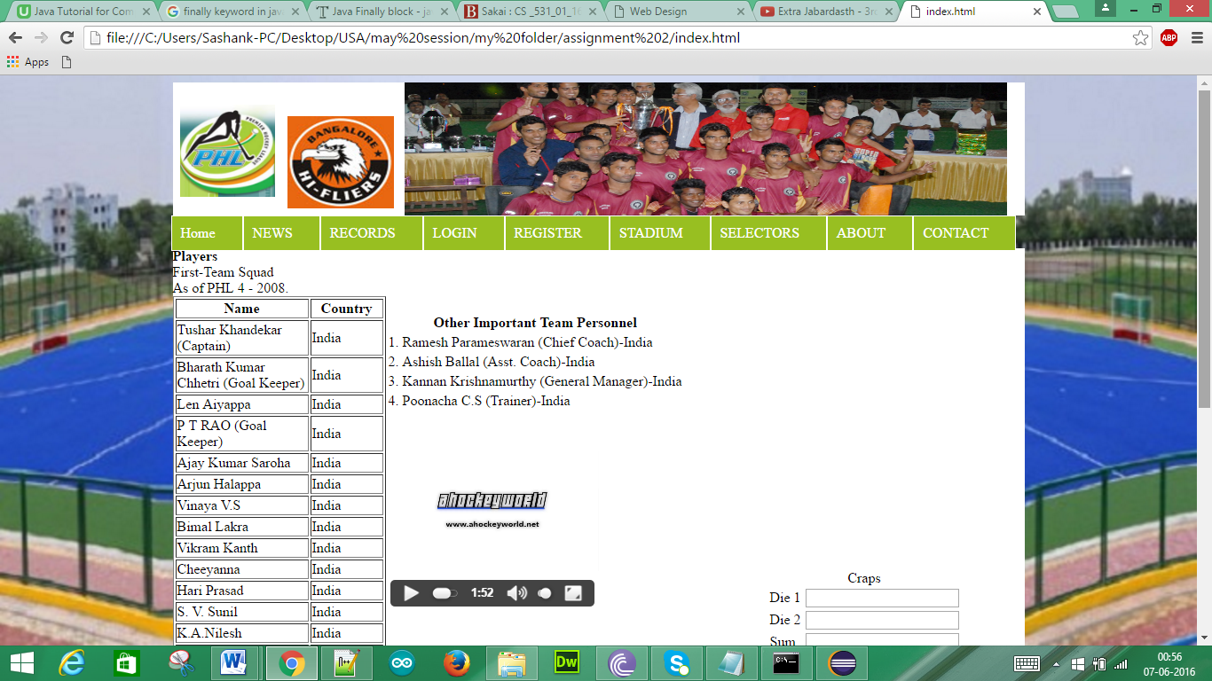

This is how the video will be played in the page

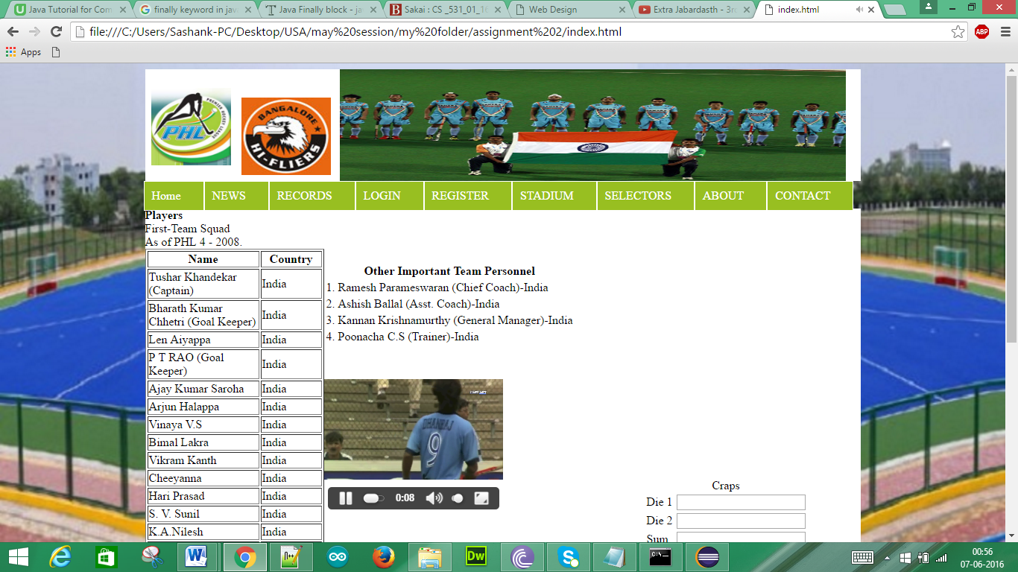

2. **FIGURE TAG**: The figure tag is used to insert the figure into the Web Page. <figure>…</figure>. The following is the code for the figure tag.

CODE:

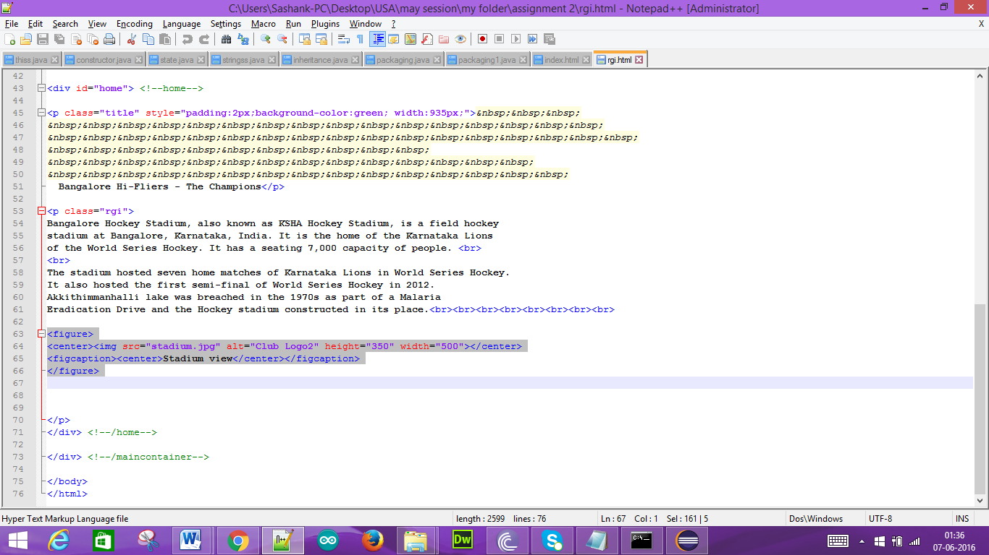

This is the figure that has been inserted in the Club Page

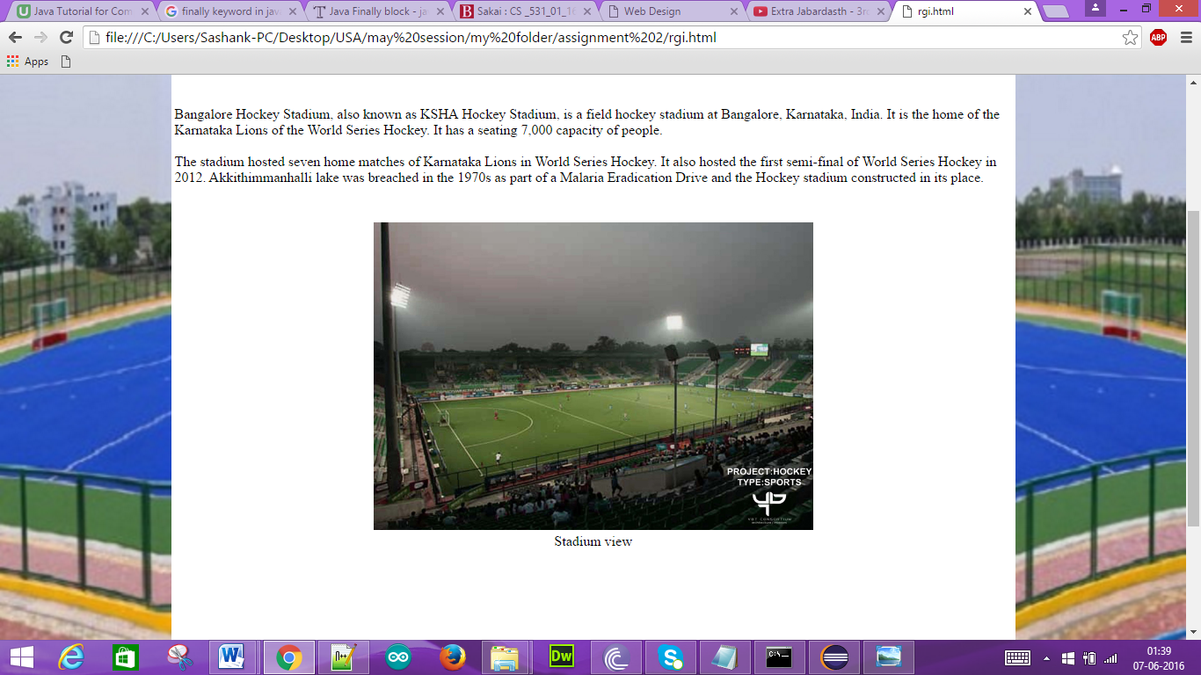

3**. FIGURE CAPTION**: This tag is used to provide the caption that has been inserted in the Club Page.

<figcaption>…</figcaption>. The following is the code for the figure caption tag.

CODE:

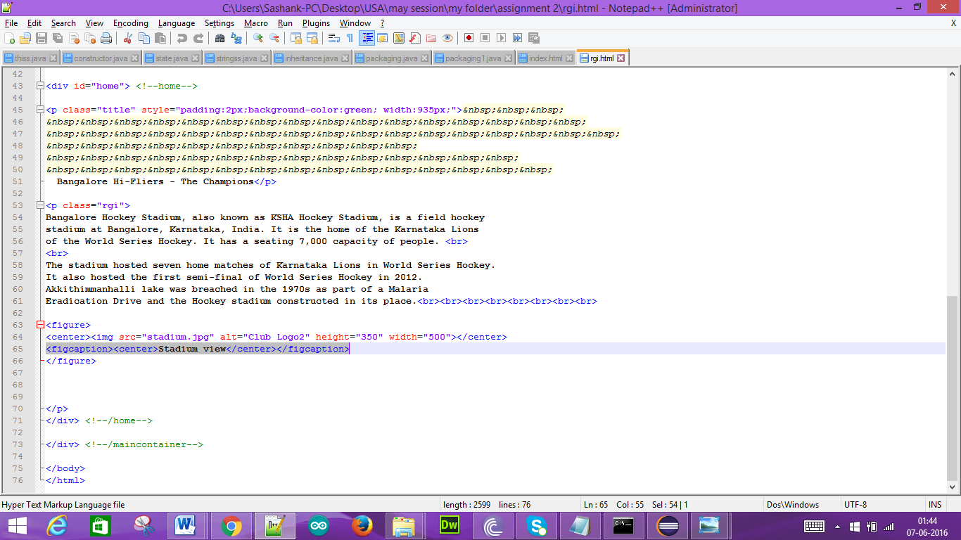

This is the caption that has been given to the figure that has been inserted.

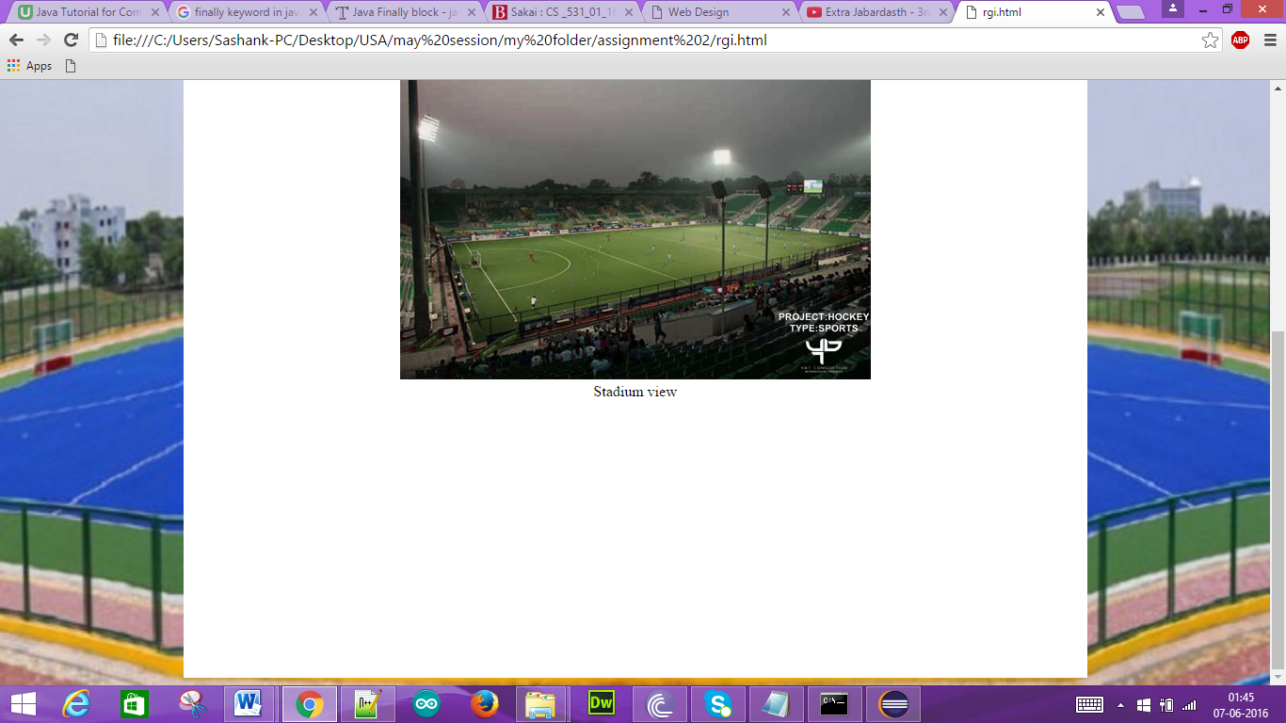

4. **MARQUEE TAG**: This tag is used to provide the scrolling on the page. <marquee>…</marquee>. The following is the code for the marquee tag.

CODE:

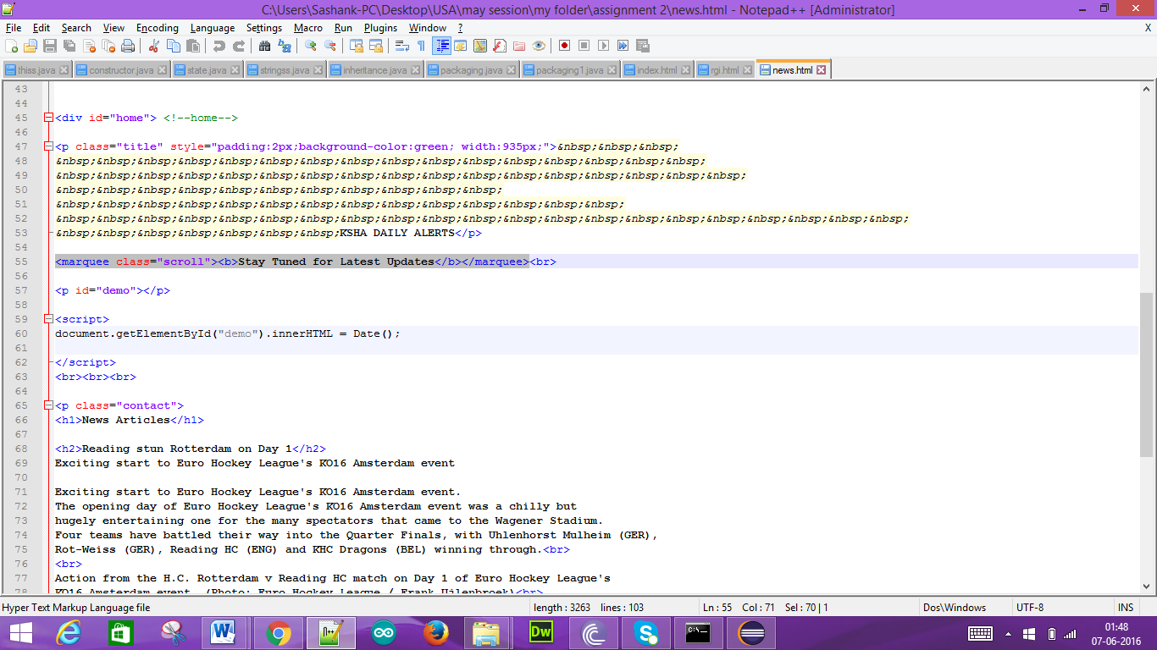

This is the way in which the scrolling has been done in the Club page.

1.

2.



3.



4.



5. **SUMMARY TAG**: This tag is used to inform the user regarding the complete summarized details.

<summary>…</summary>. The following is the code for the summary tag.

CODE:

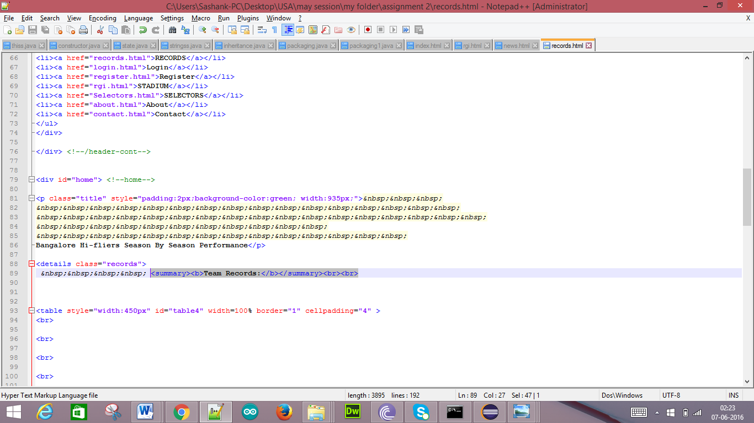

This is the summary that has been provided in the Club page.

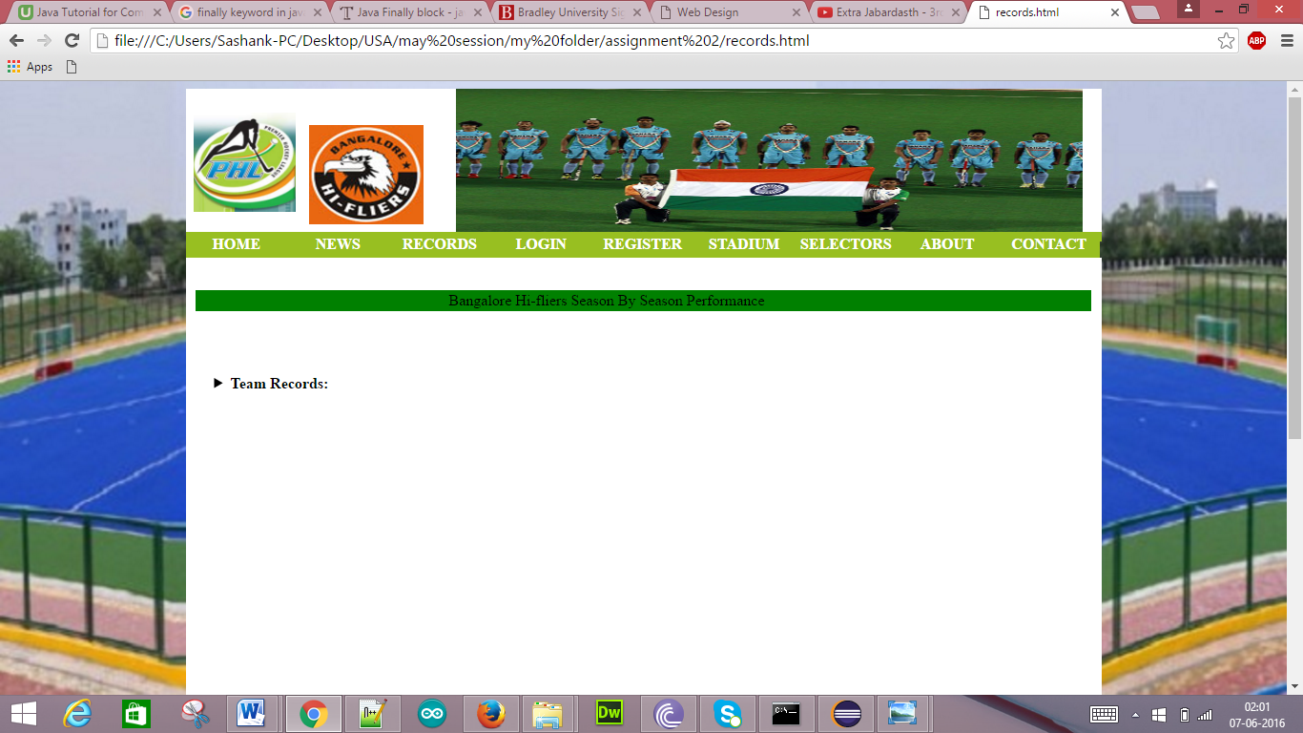

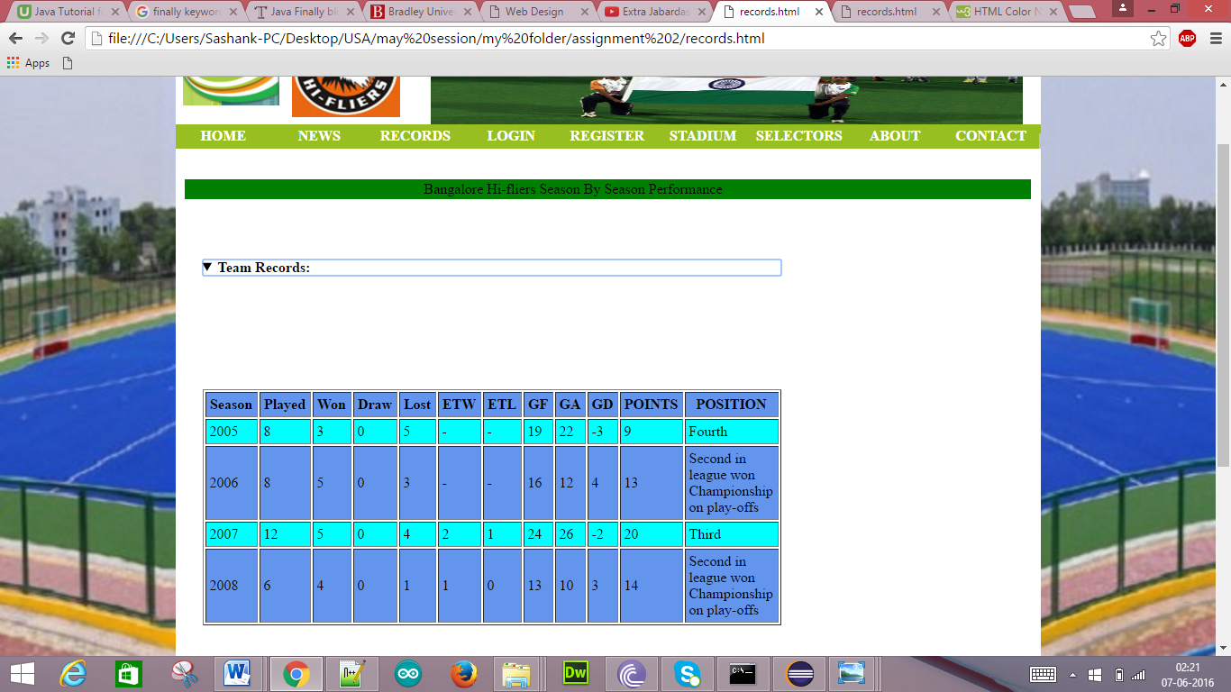

**B. HTML Web Pages with JavaScript**

1. **Input data validation**

First name validation:

Here the First Name field is empty

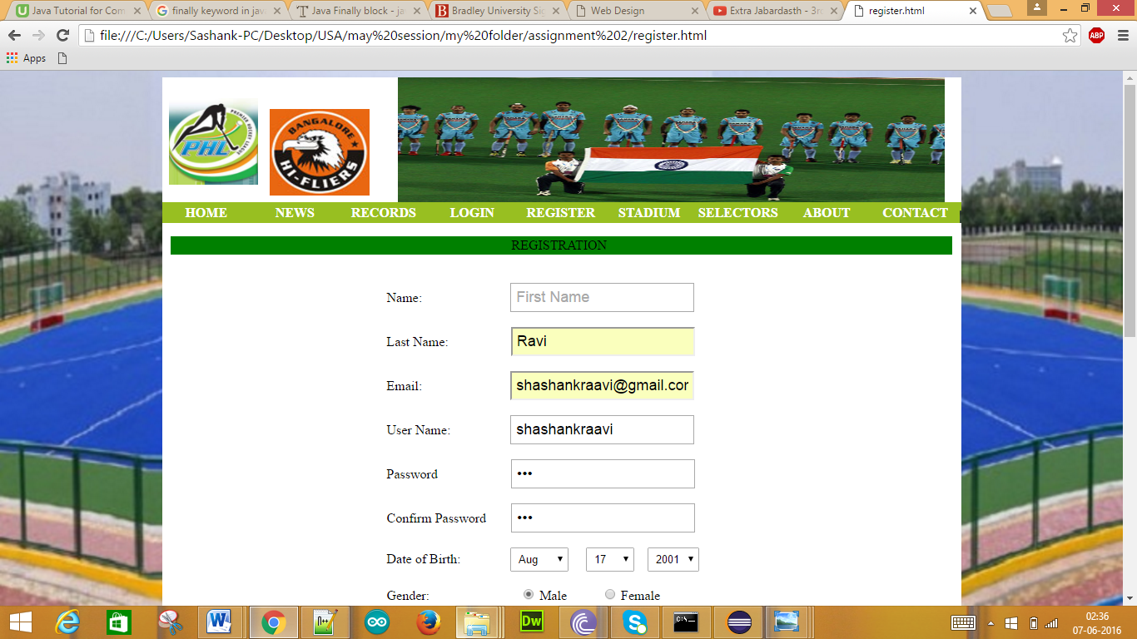

Without entering First Name if we click submit we get the following pop-up

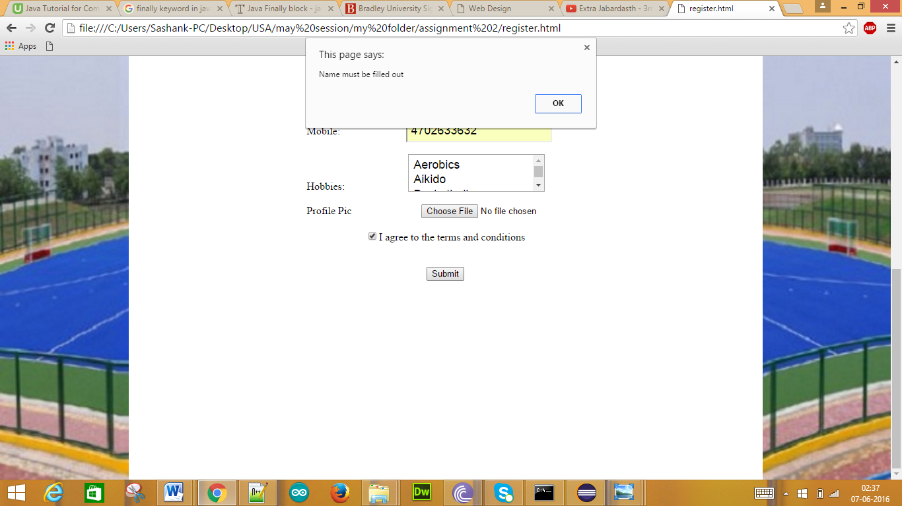

When we click OK then we get the following display

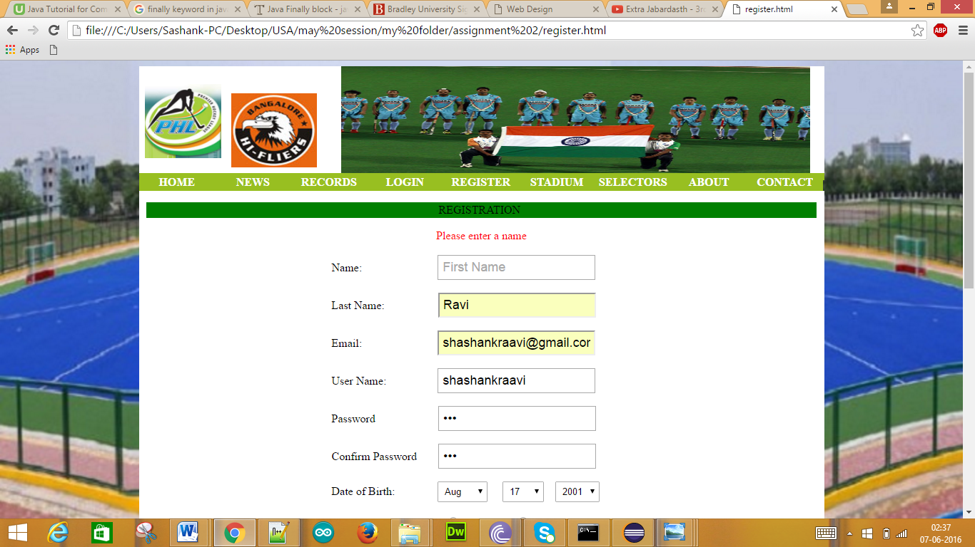

Last Name Validation:

Here the Last Name field is empty

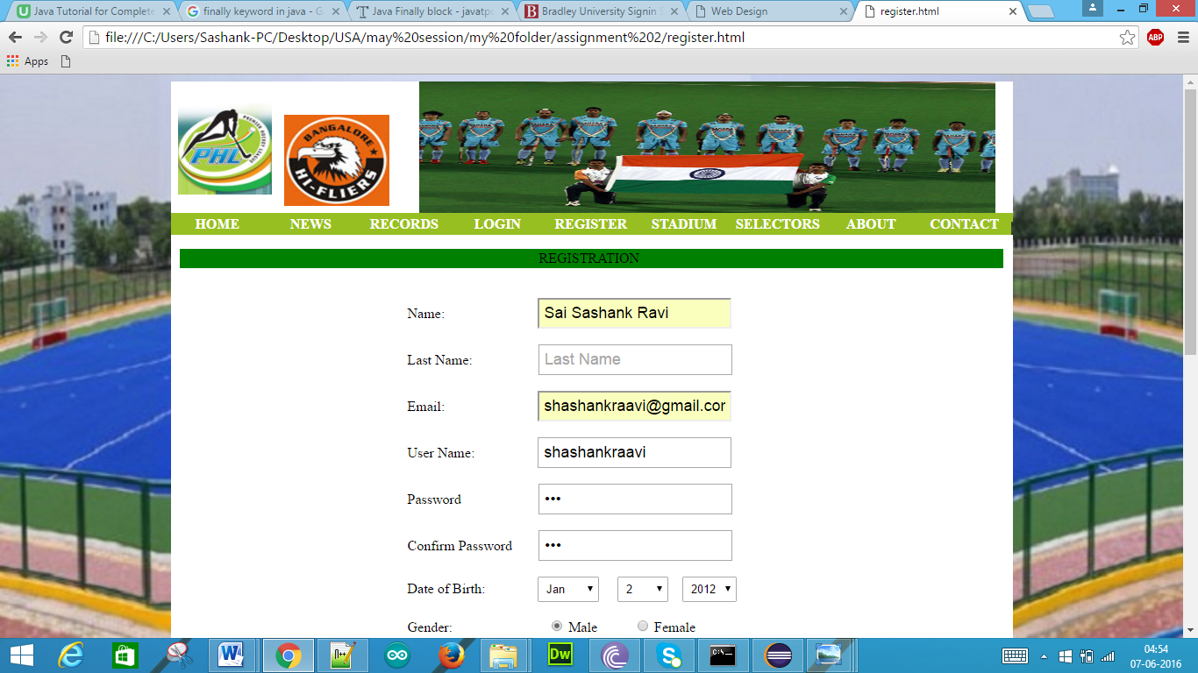

Without entering Last Name if we click submit we get the following pop-up

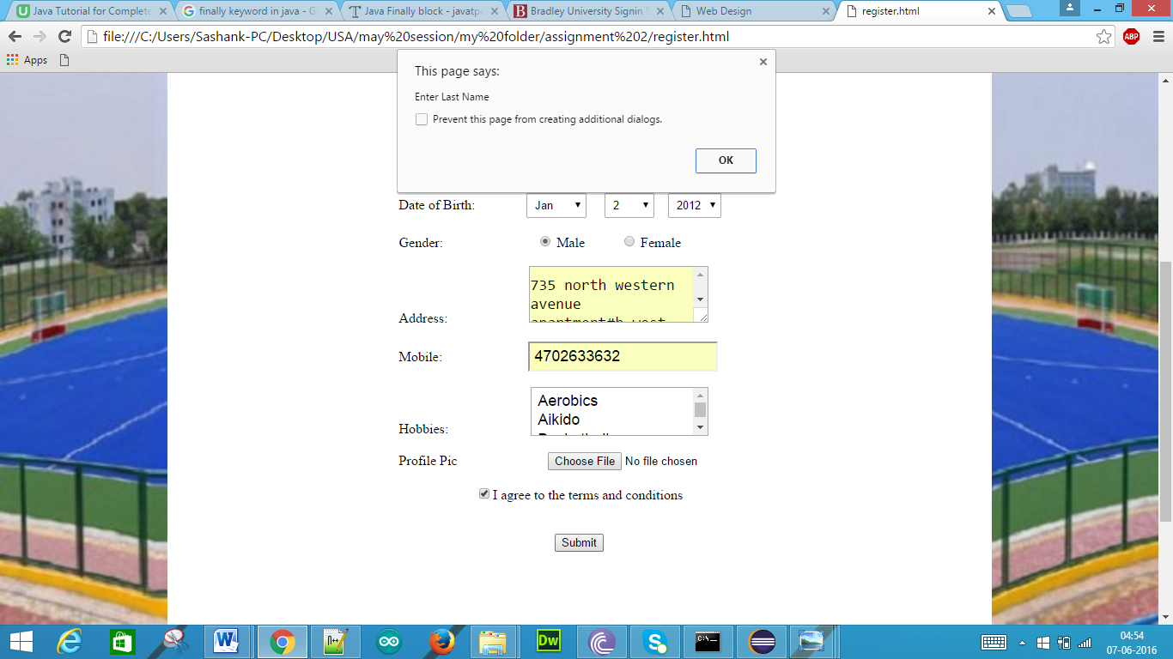

When we click OK then we get the following display

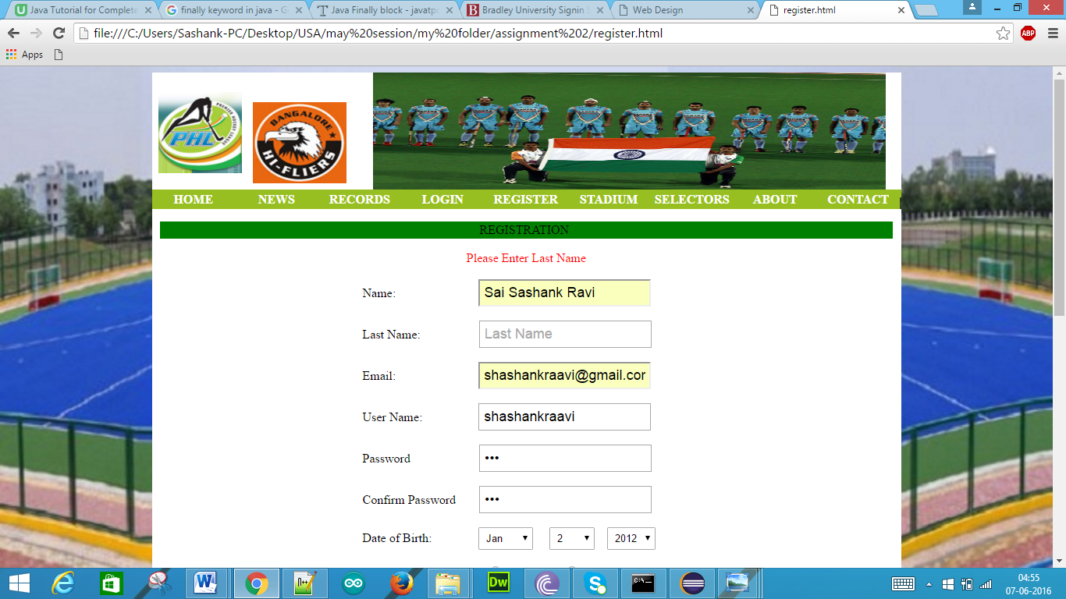

Email Validation:

Here the Email field is empty

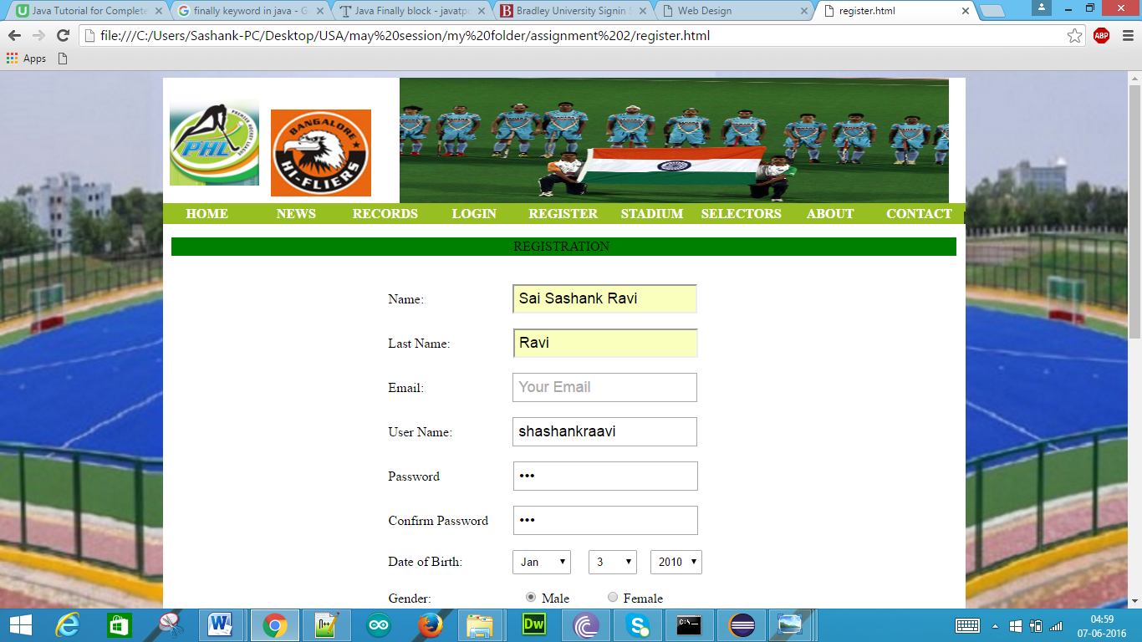

Without entering Email if we click submit we get the following pop-up

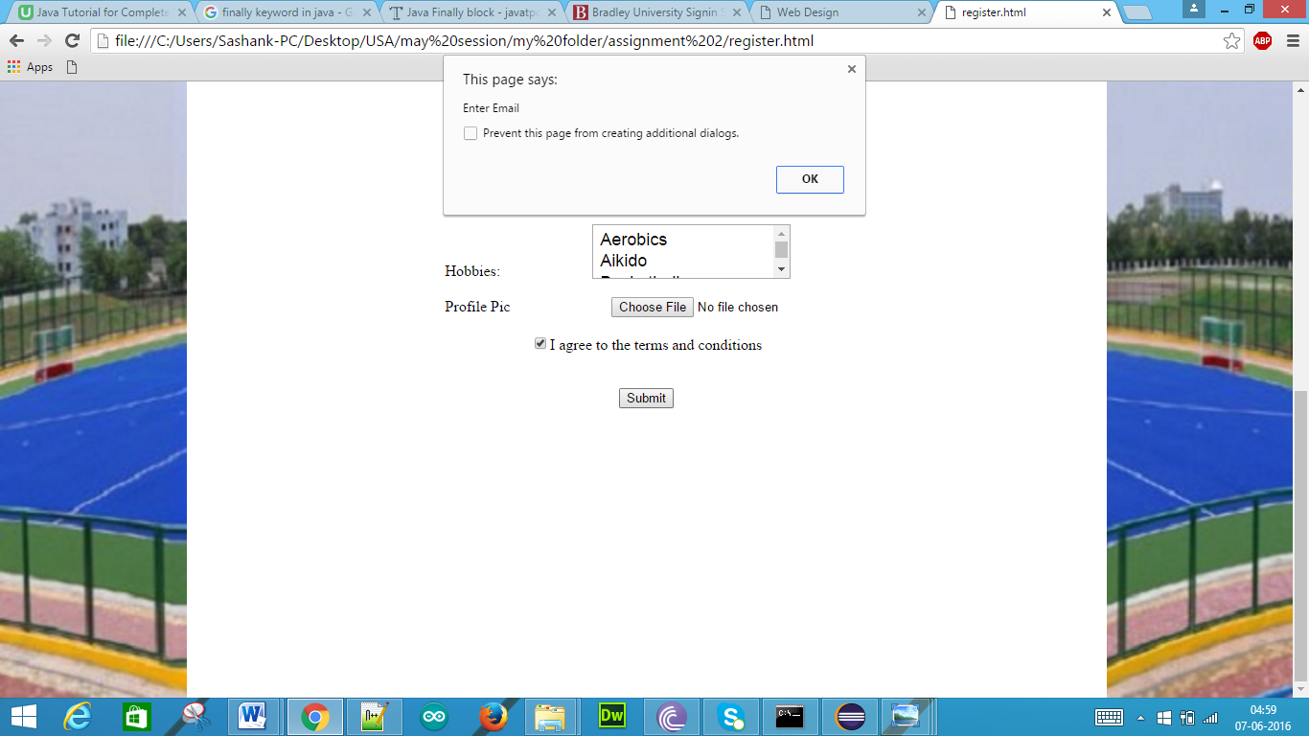

When we click OK then we get the following display

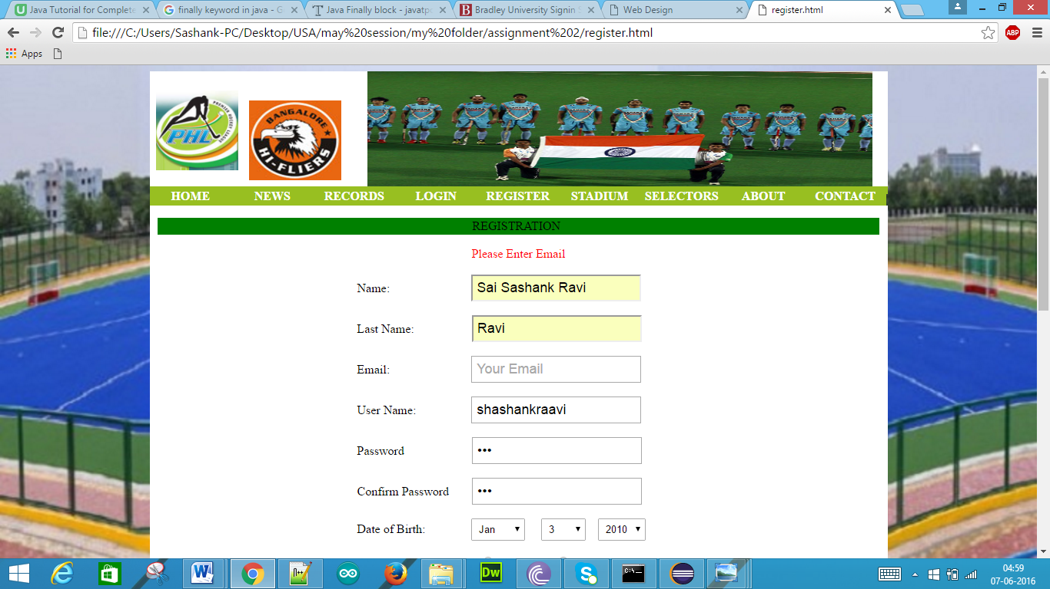

User Name Validation:

Here the User Name field is empty

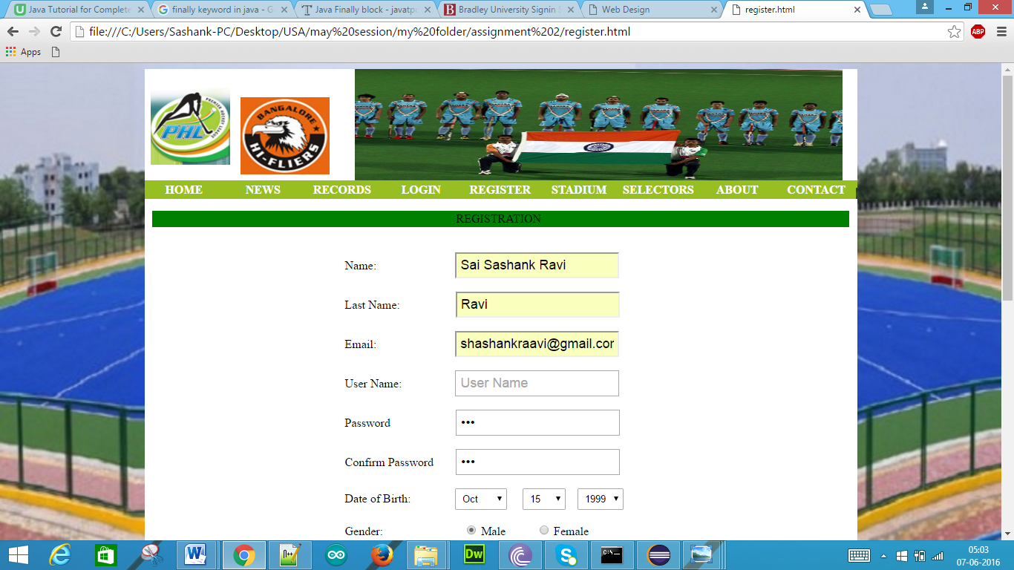

Without entering User Name if we click submit we get the following pop-up

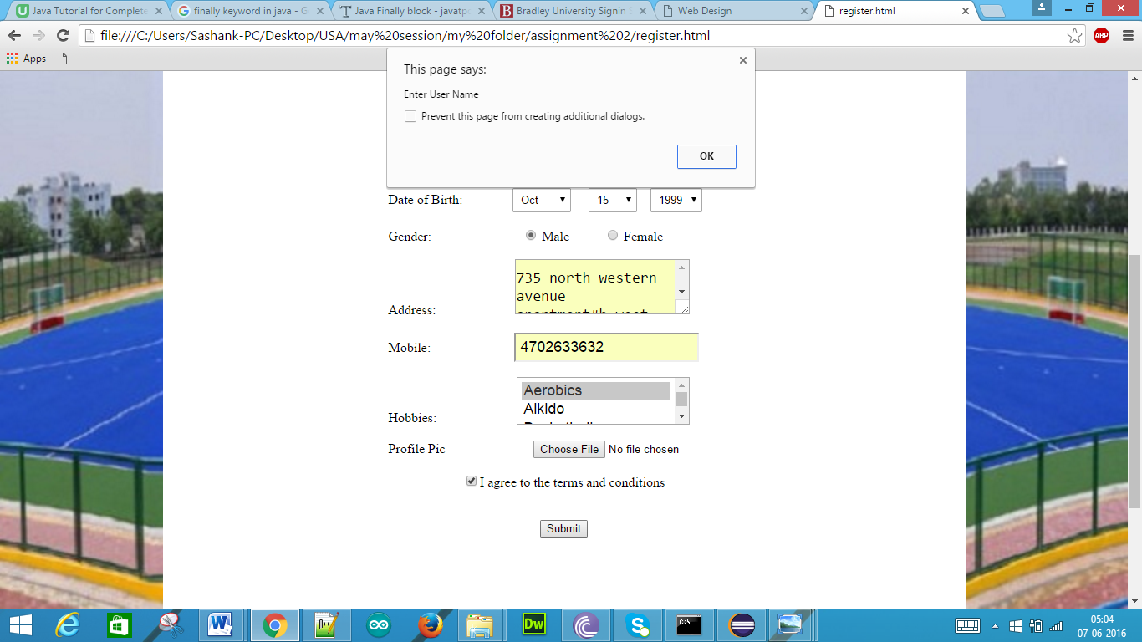

When we click OK then we get the following display

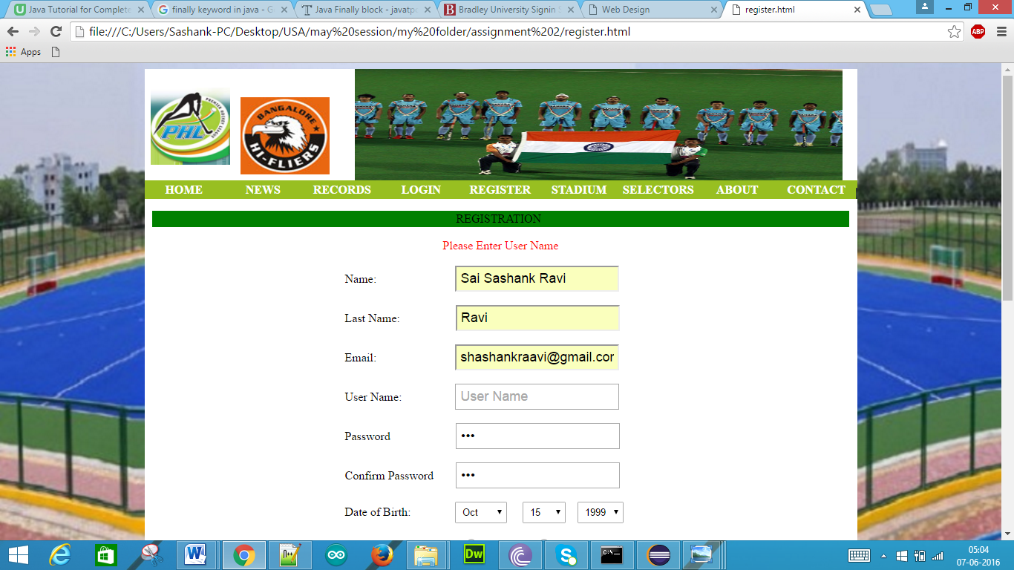

Password Validation:

Here the password field is empty

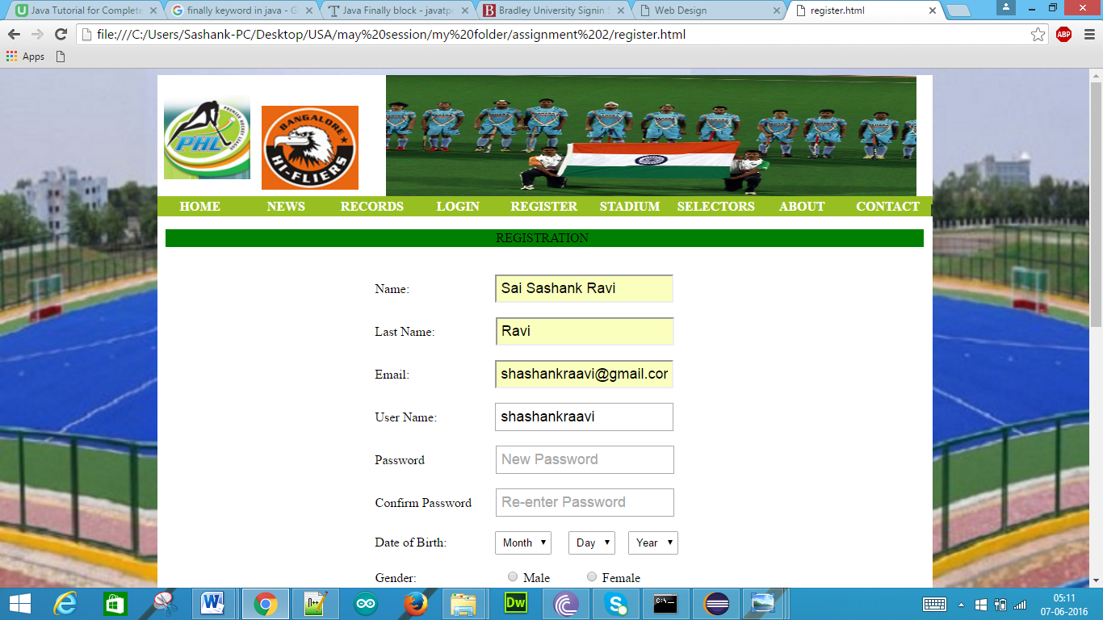

Without entering password if we click submit we get the following pop-up

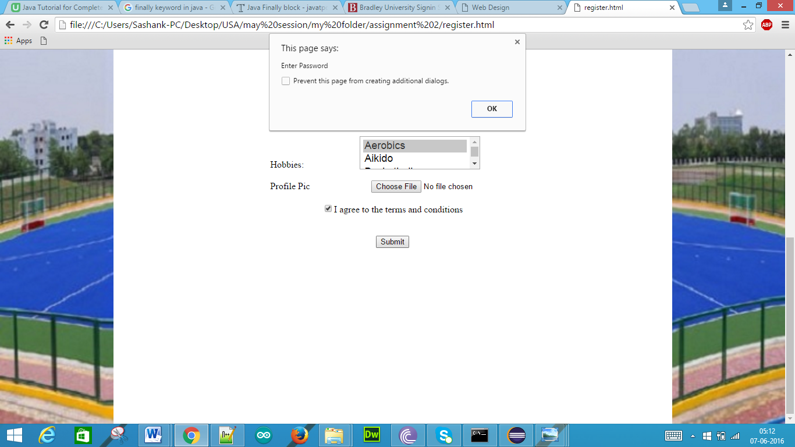

When we click OK then we get the following display

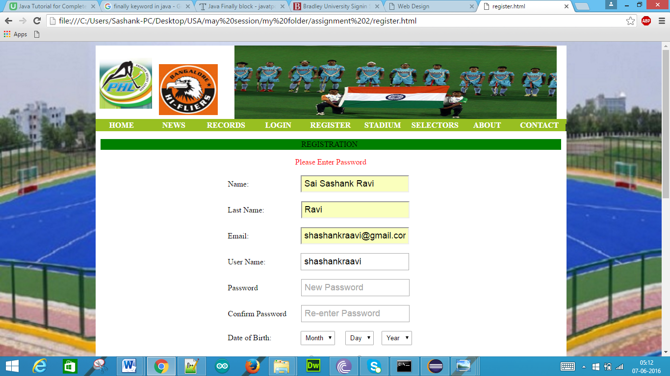

If we enter different characters in the password fields

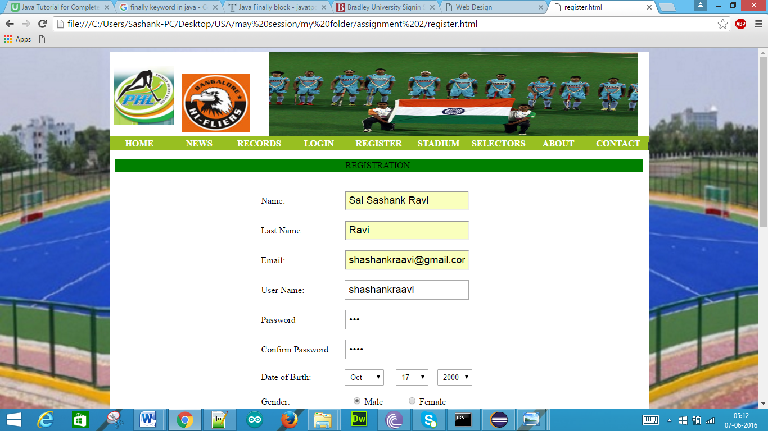

If same number of characters but not same characters

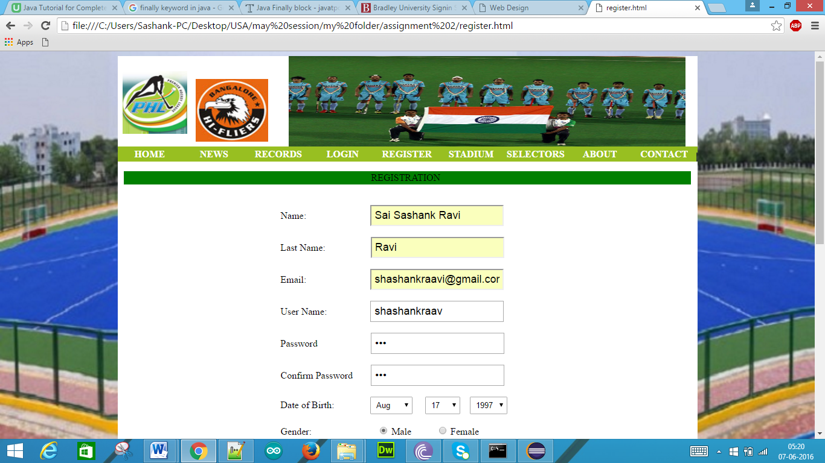

Then we get the below display

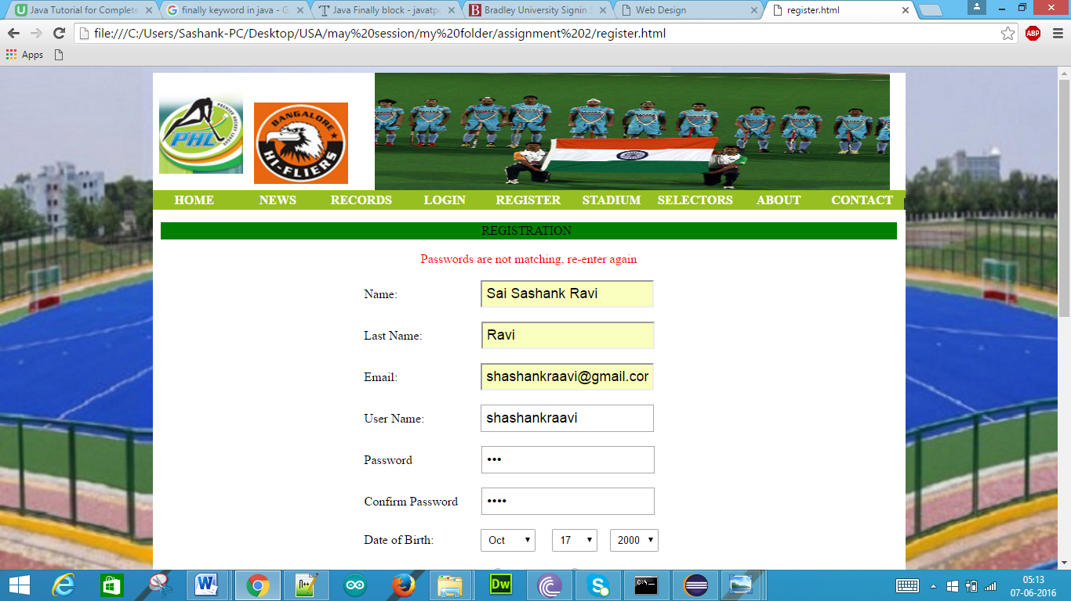

Date of Birth Validation:

Here the Date of Birth field is empty

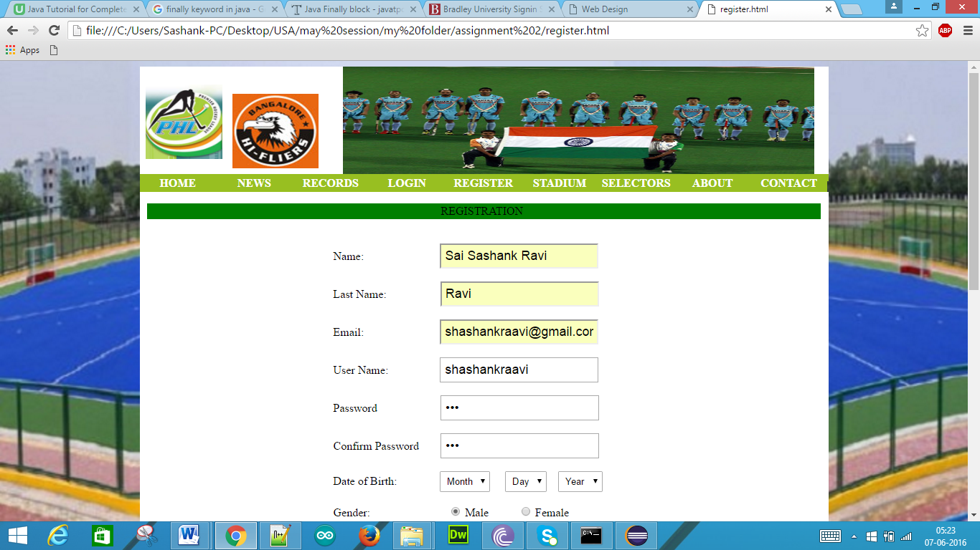

If we submit without selecting the date of birth then we get following display

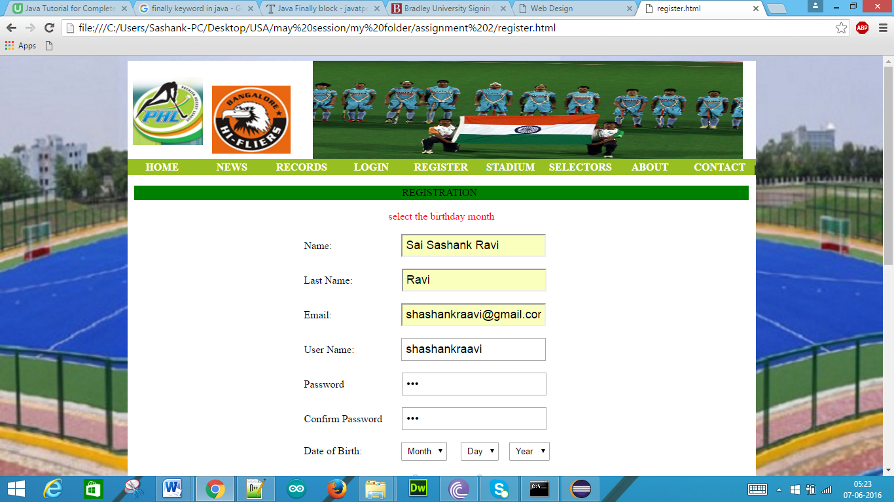

If we just select the month and click submit

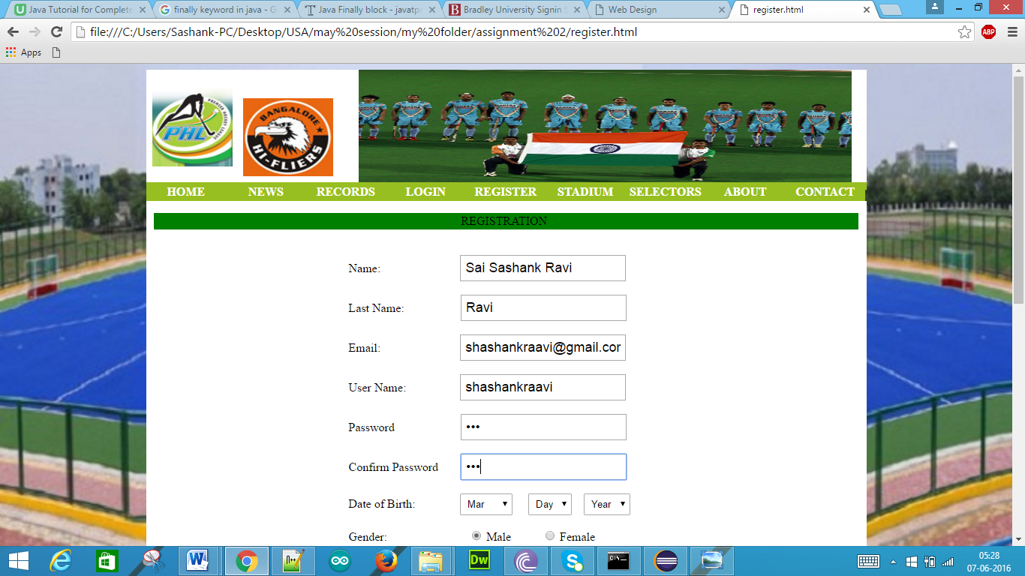

Then we get the following display

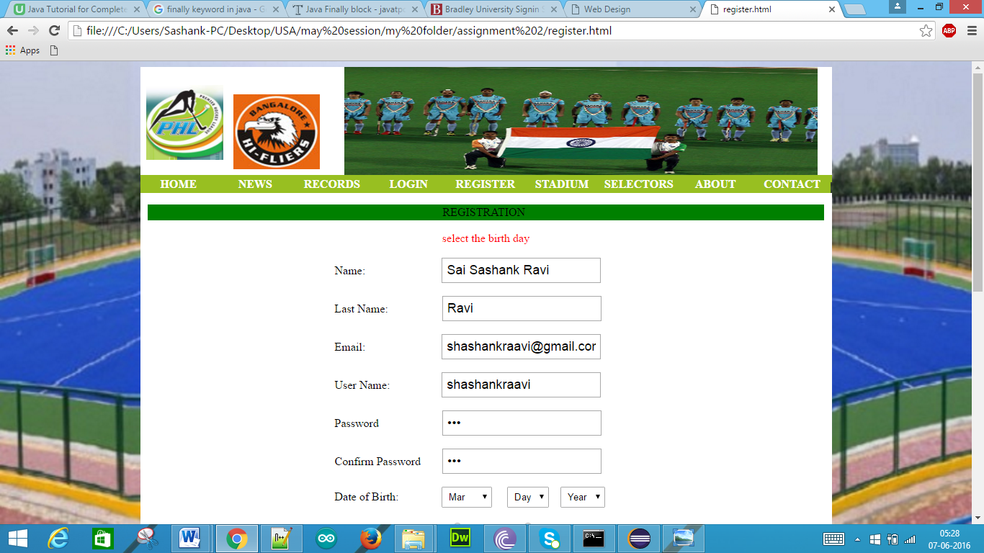

If we select the month, day and click submit

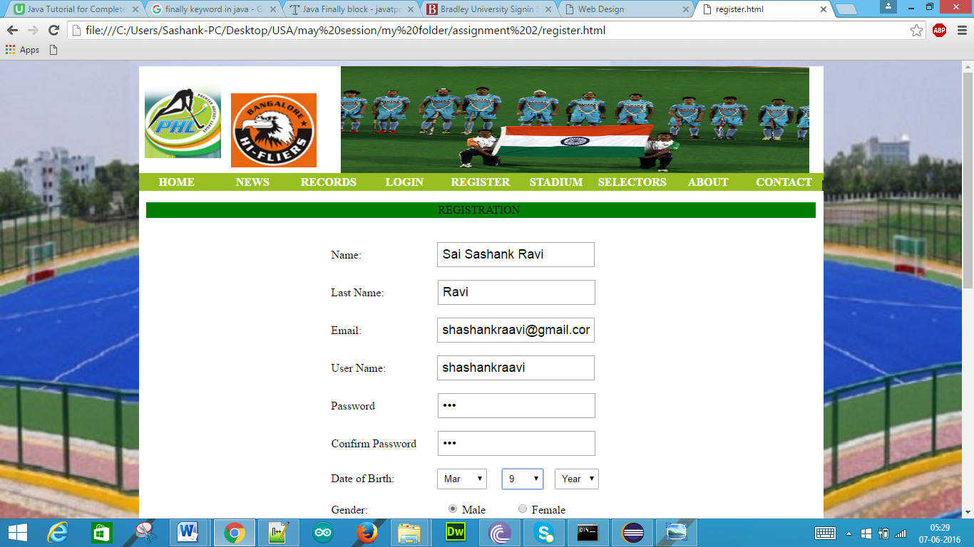

Then we get the following display

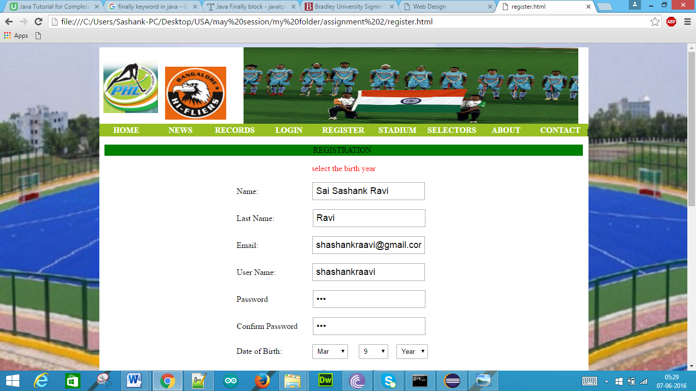

Mobile Validation:  
Without entering the mobile number if we click submit

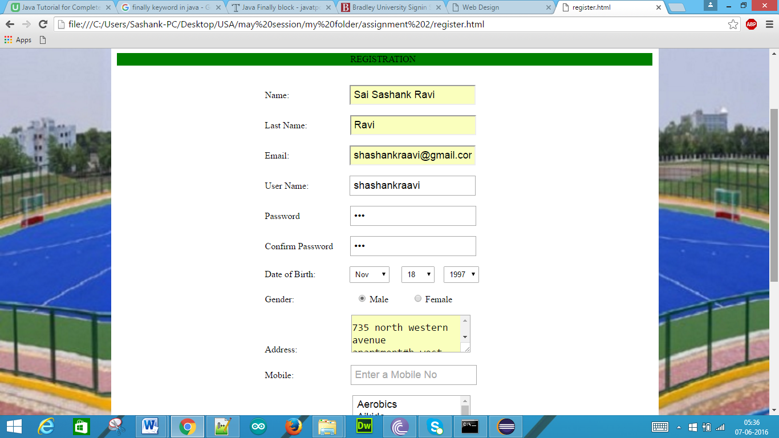

Then we get the following display

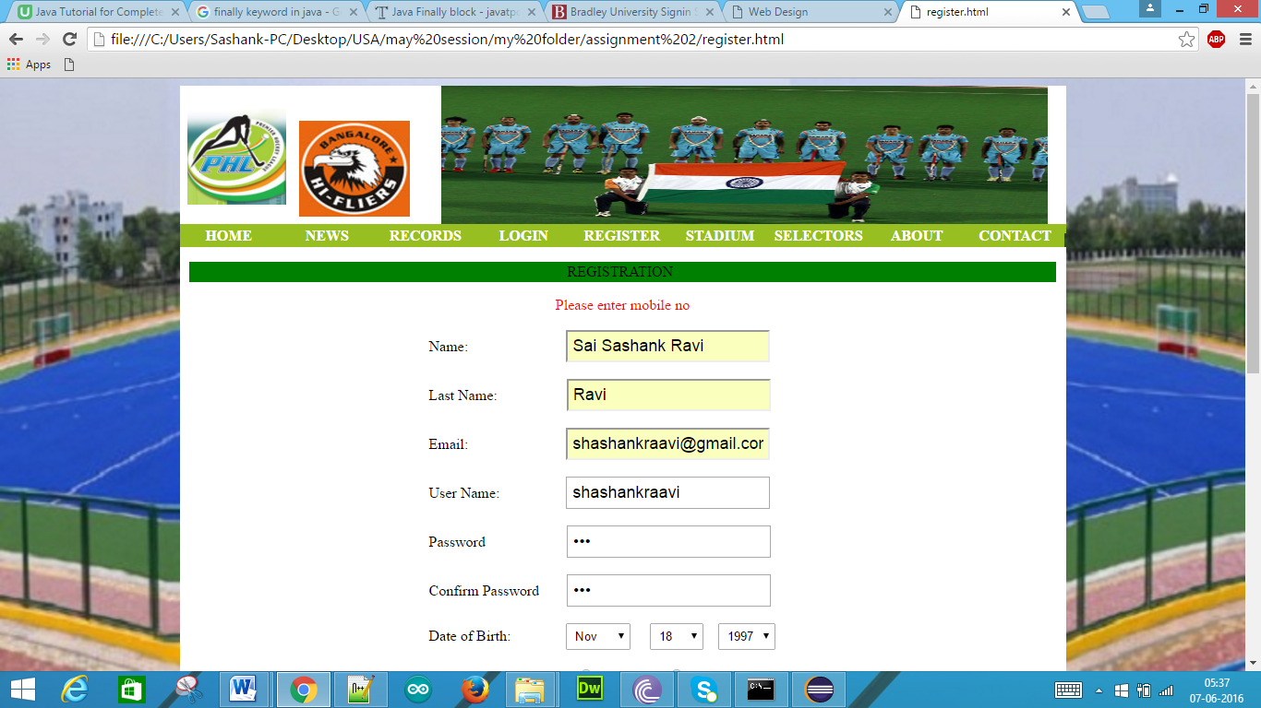

Terms and Conditions Validation:

Here the terms and conditions check box is unchecked

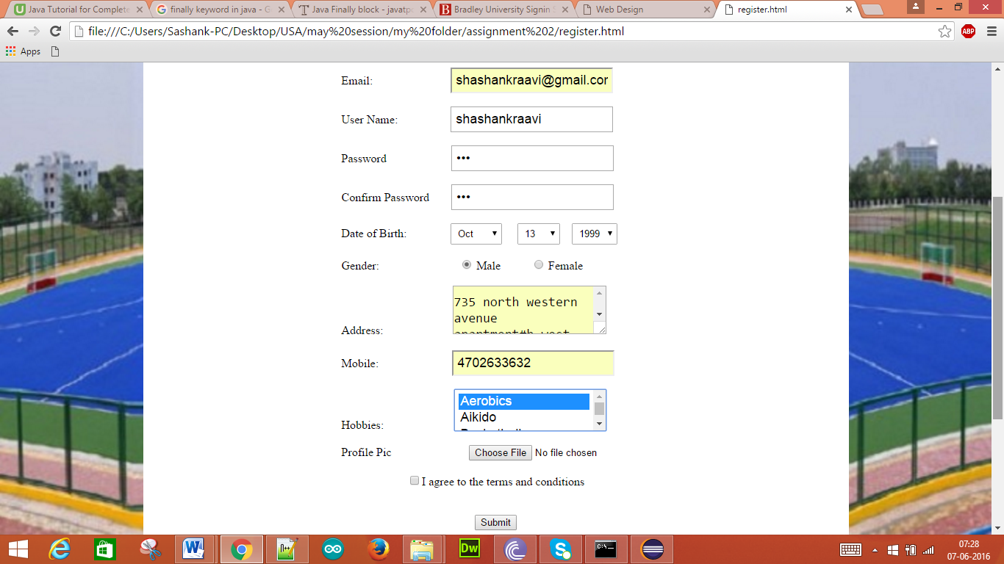

Without checking the box if we click submit we get the following pop-up

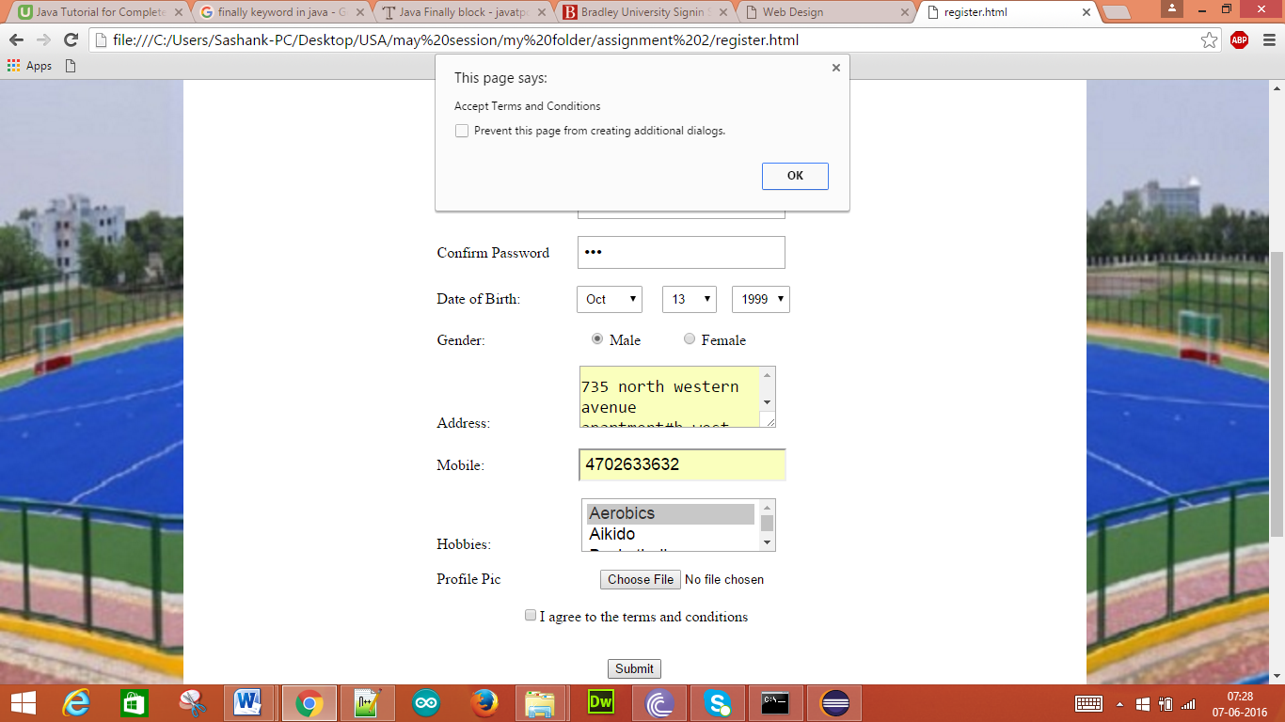

When we click OK then we get the following display

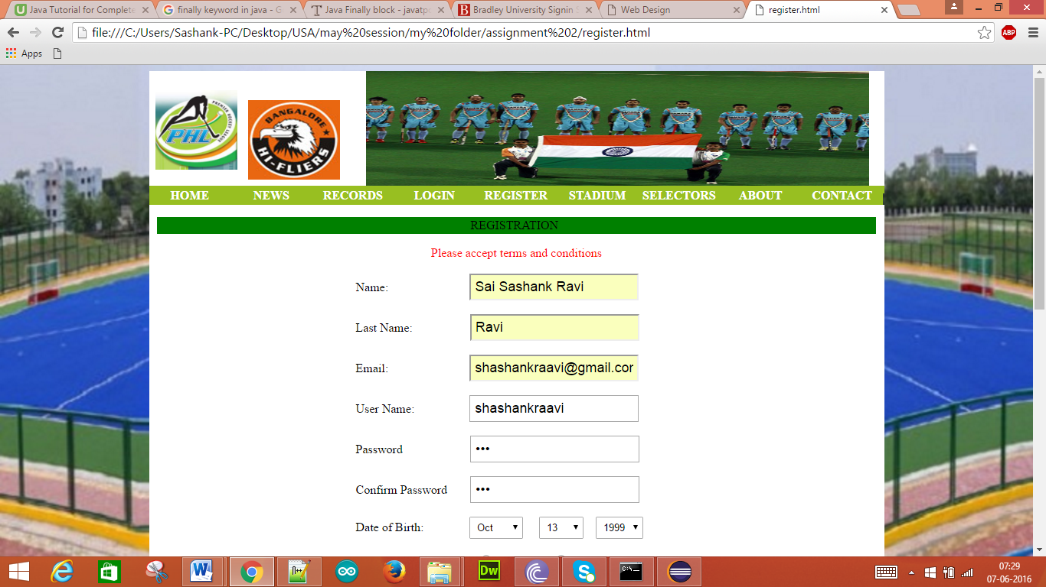

2. **Rich web page presentation**

1. Selection Control Statements:

Javascript is used for the Validation and it consists of if-else statements.

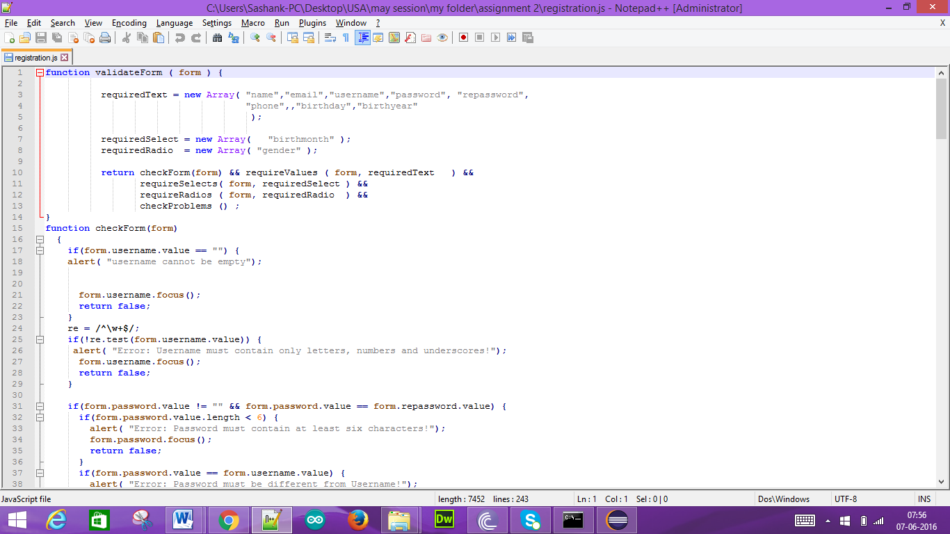

2. Repetition Control Statement:

The following table with alternate row background colors is created by using repetitive control statements

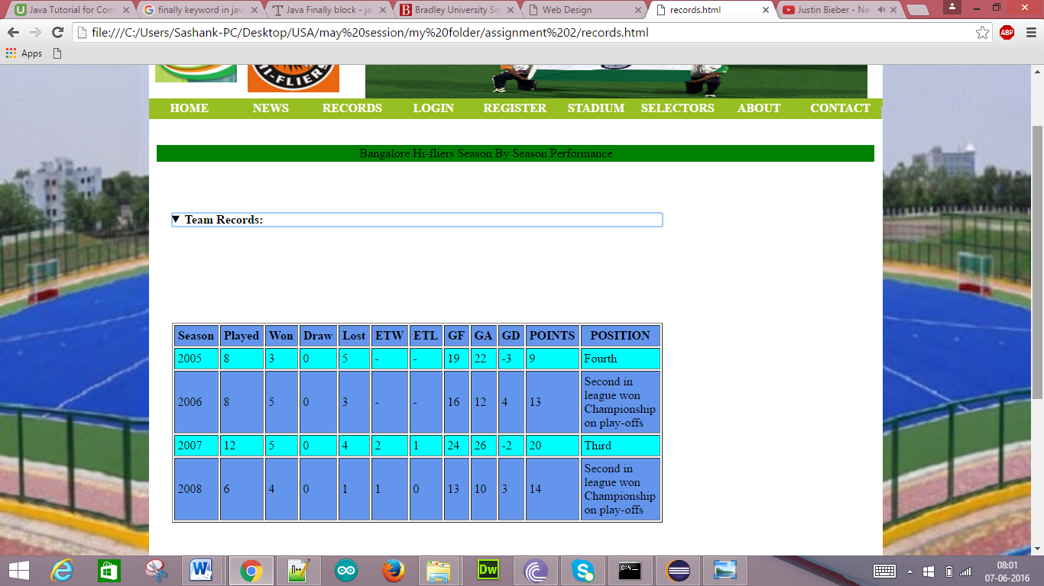

3. Functions:

Several functions are included in various html pages like registration page, events page etc..,

Registration page

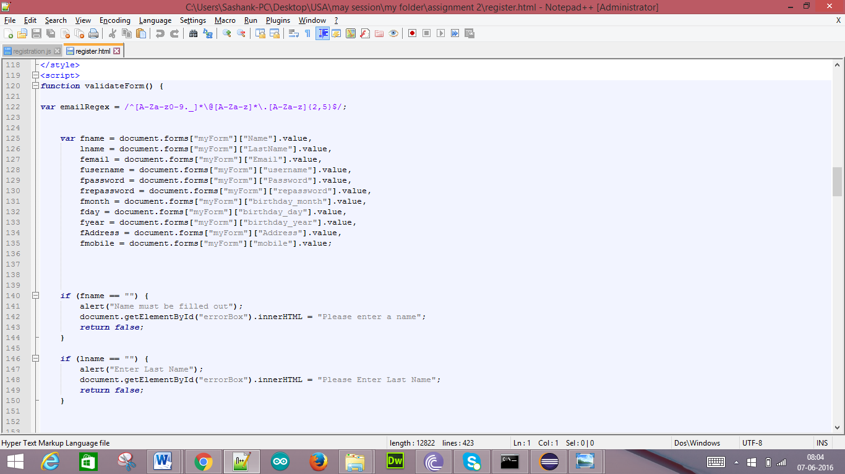

Events.html

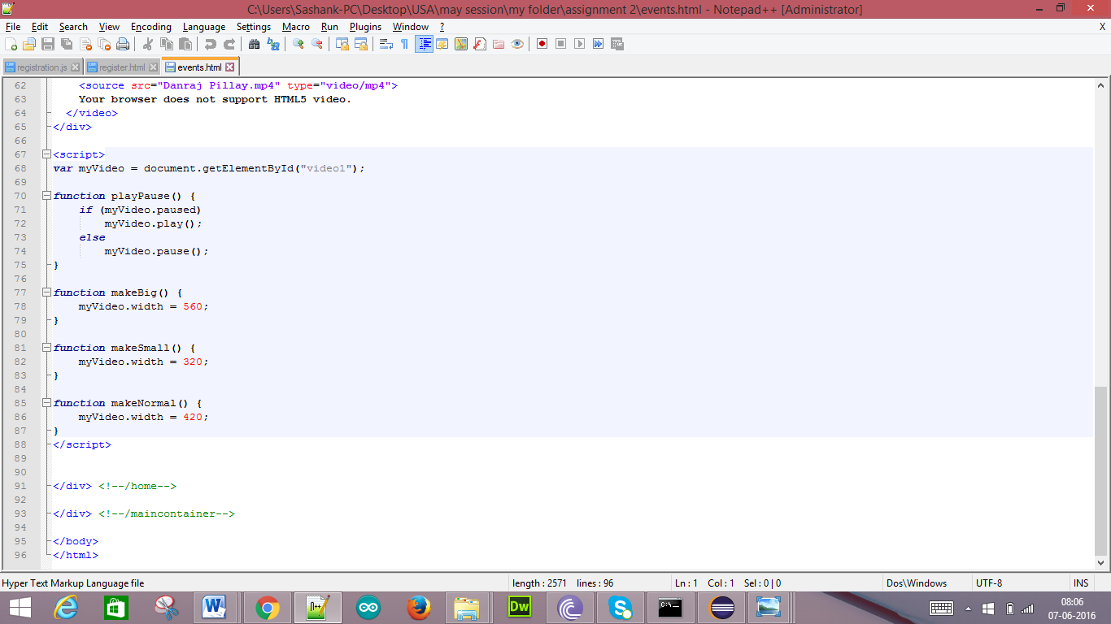

4. Arrays:

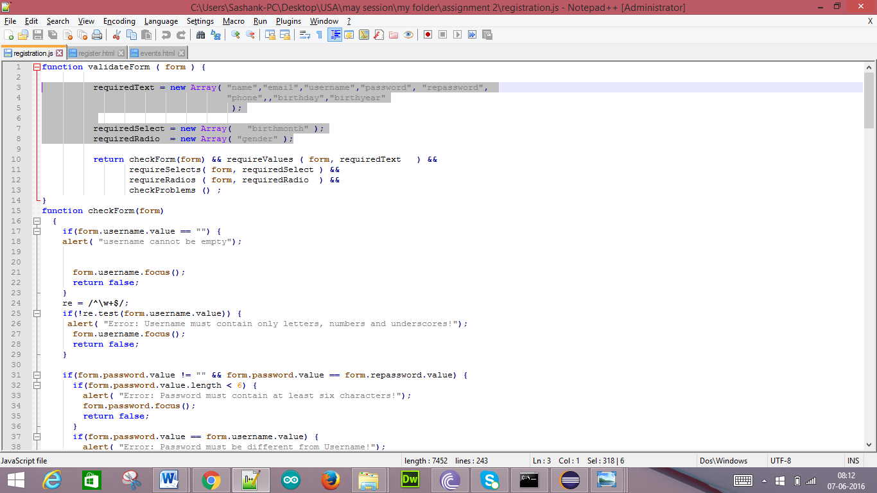

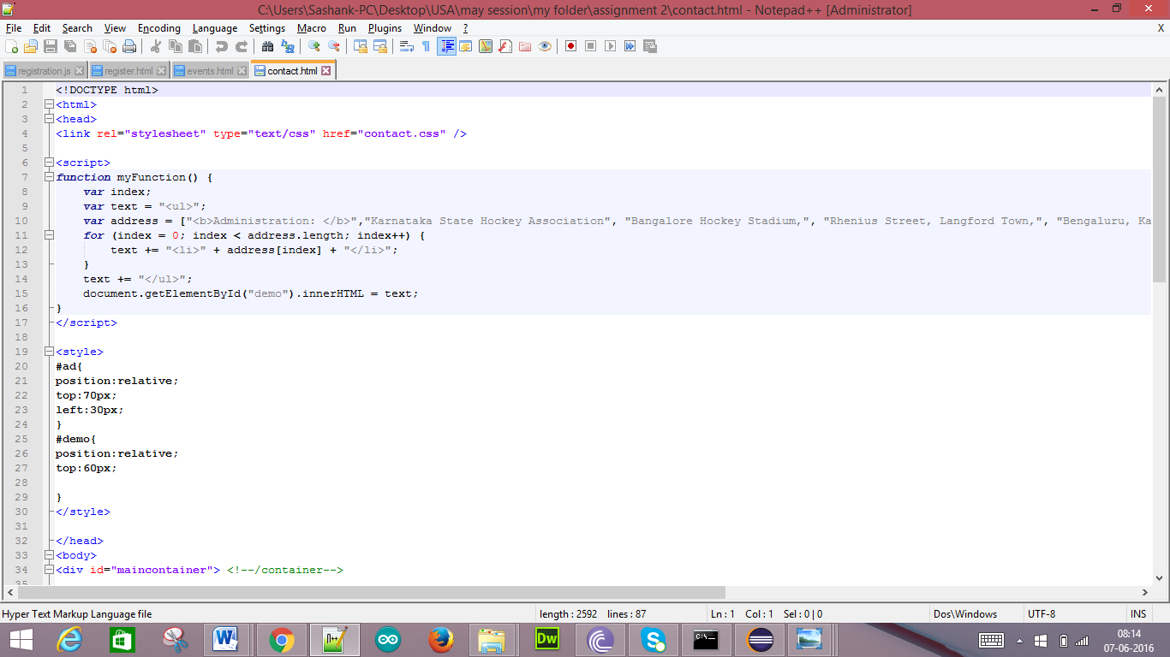

Output:

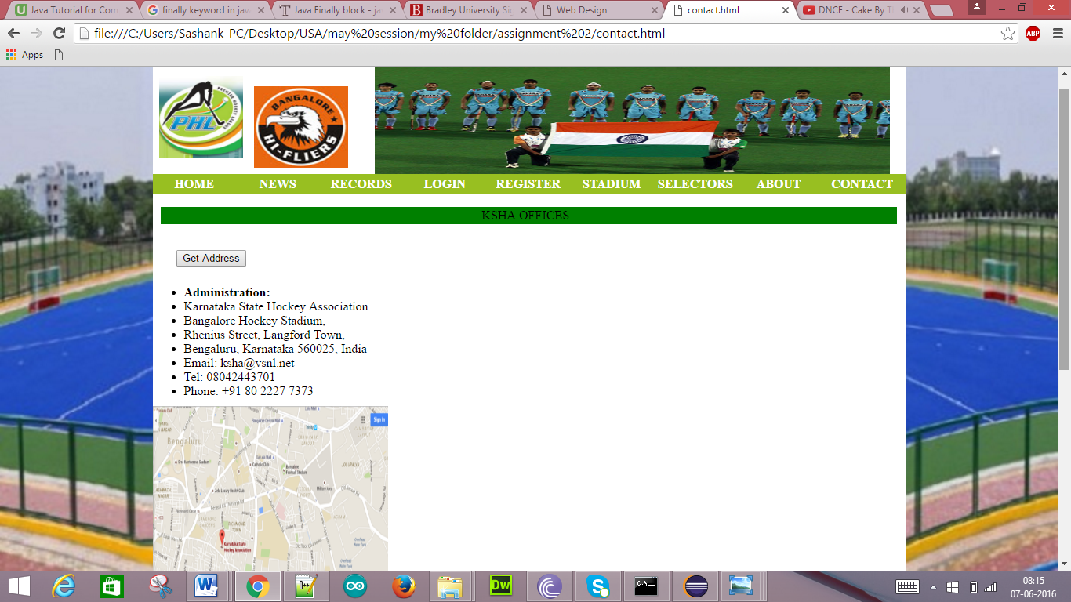

5. Objects:

Code:

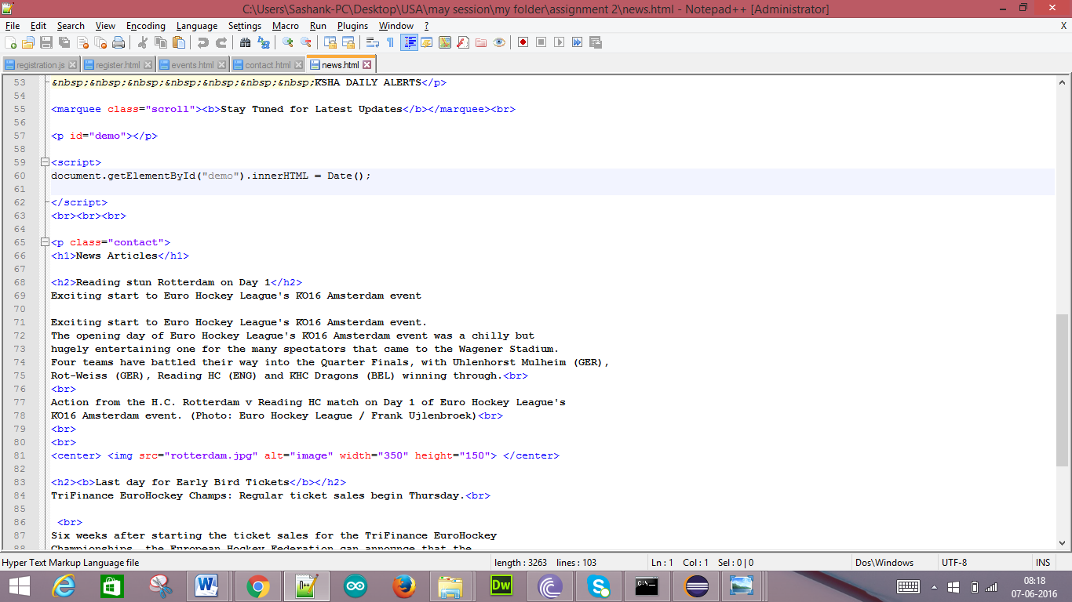

Output:



6. Events:

Code:

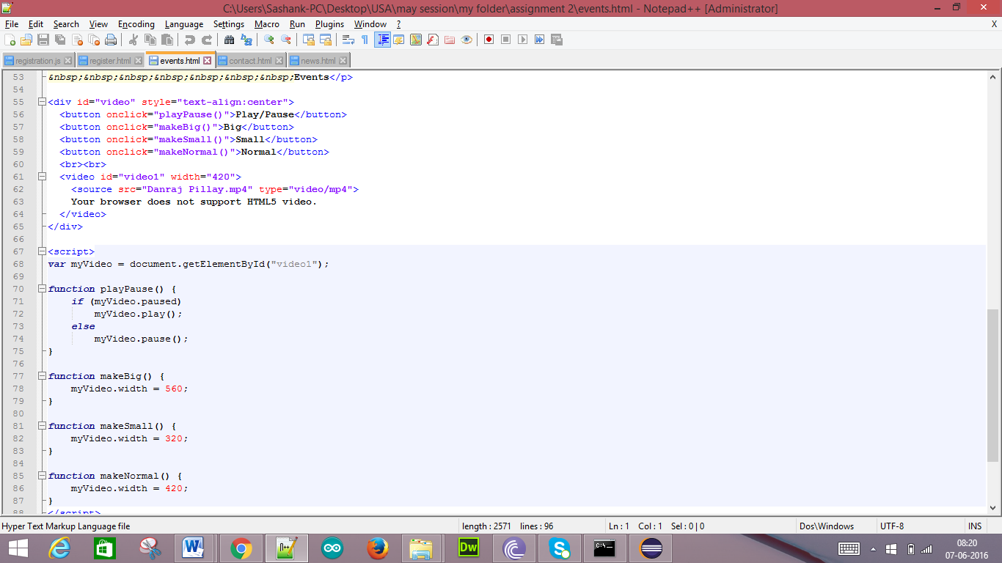

Output:

Normal:

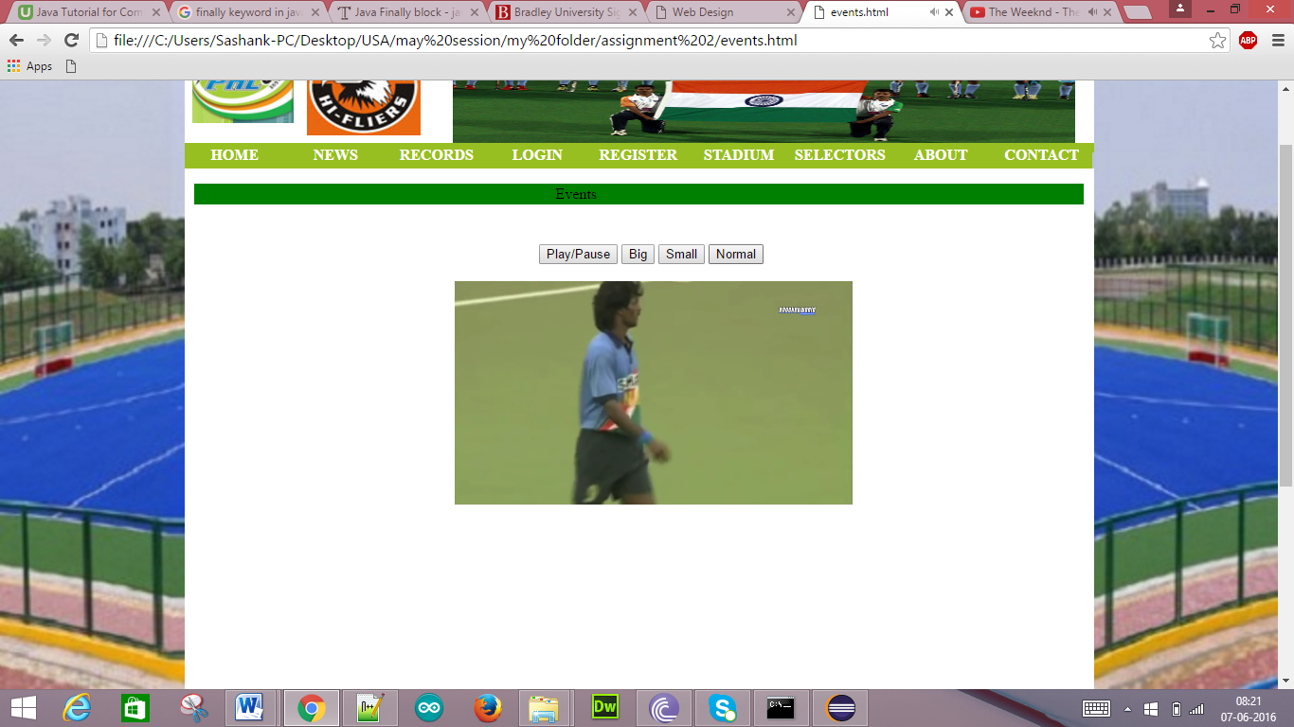

Small:

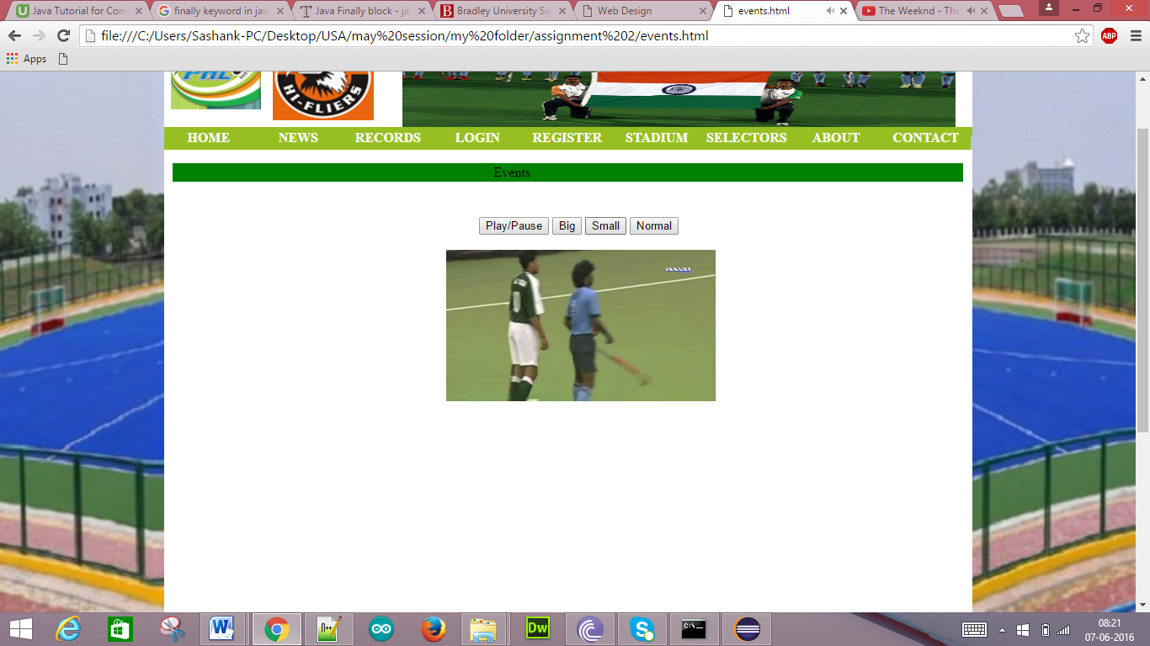

Large:

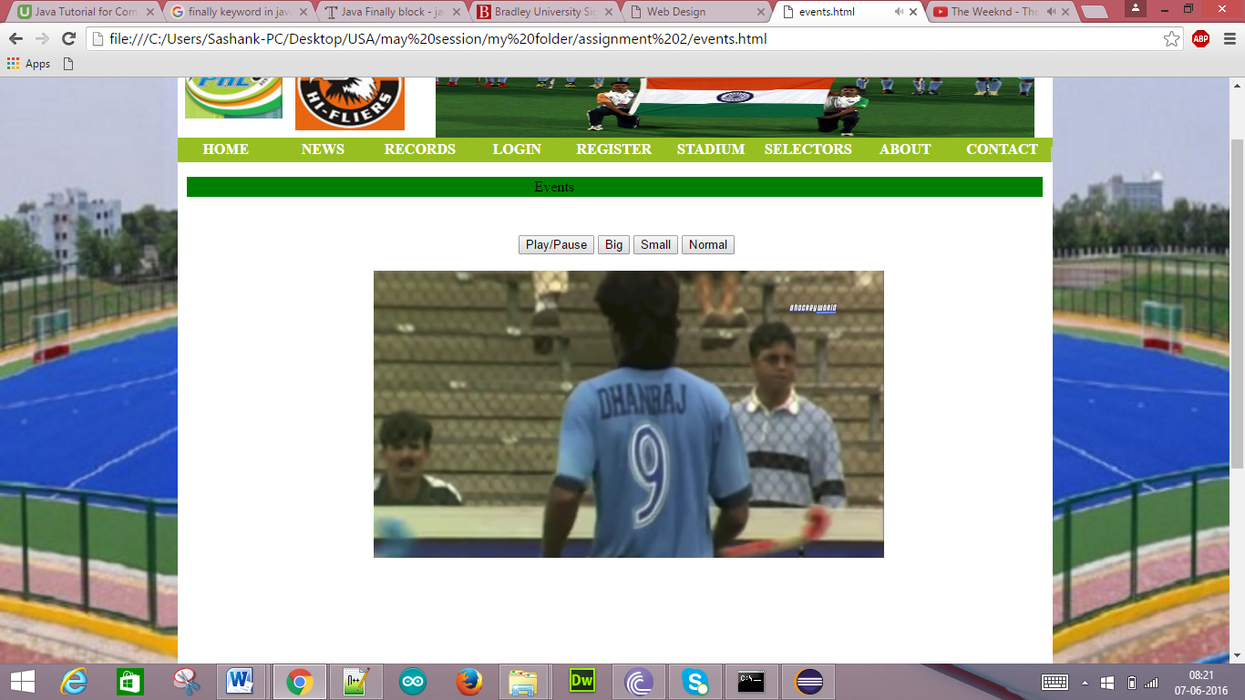

3. **Dynamic HTML presentation**

1. Pull Down Menu:

Code:

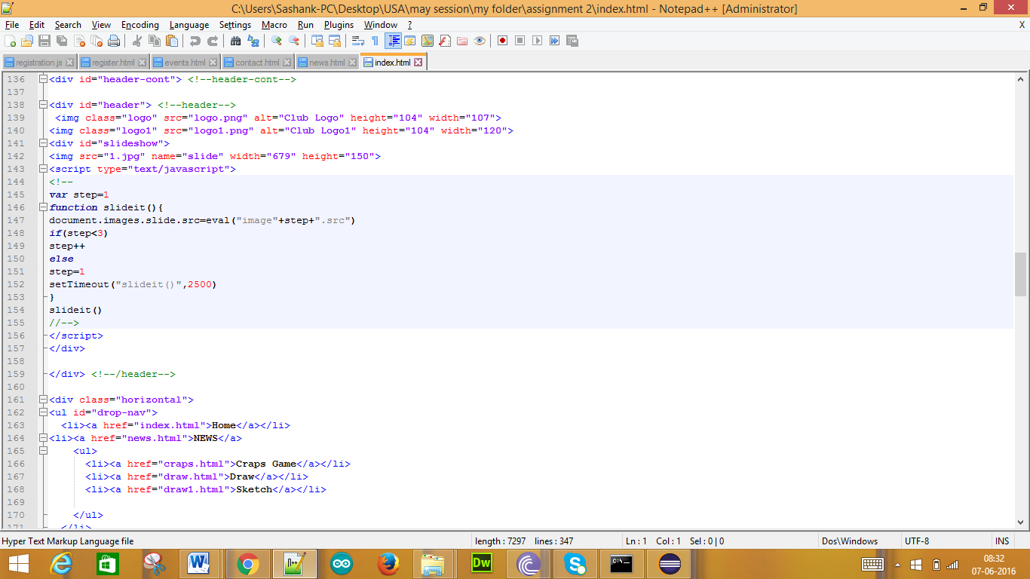

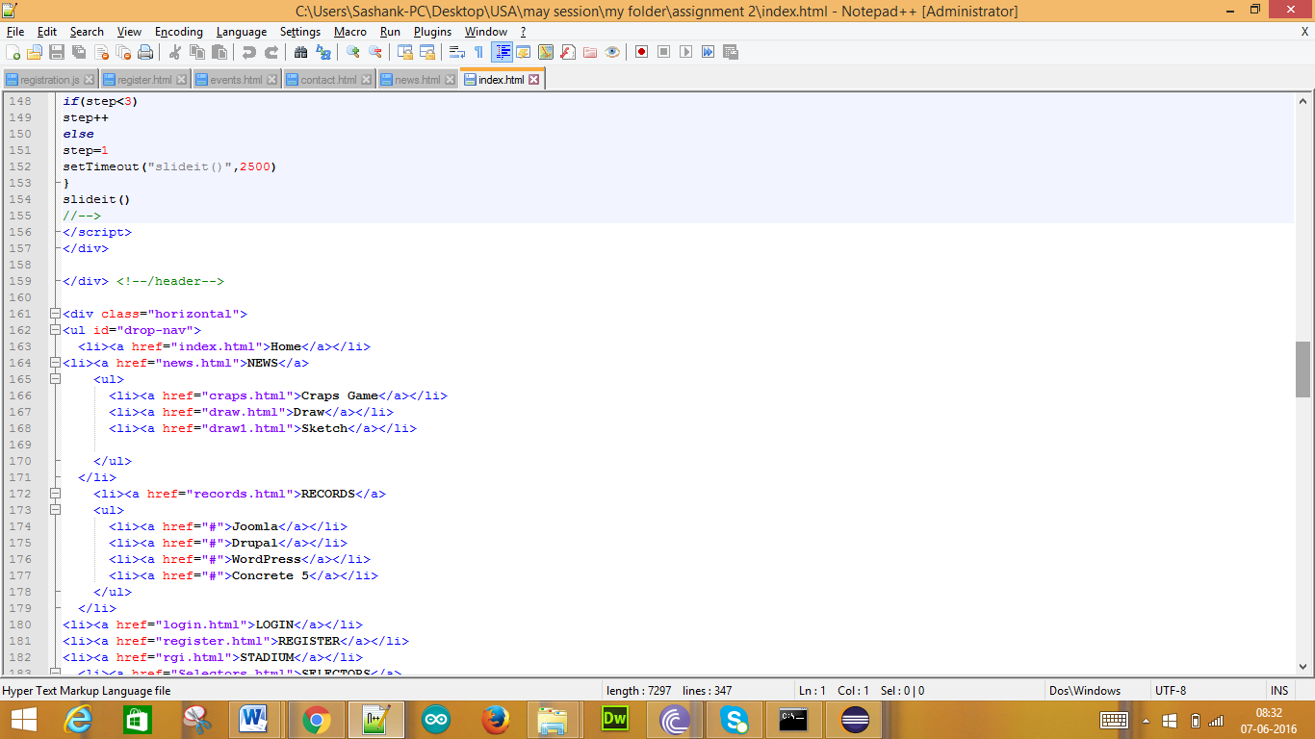

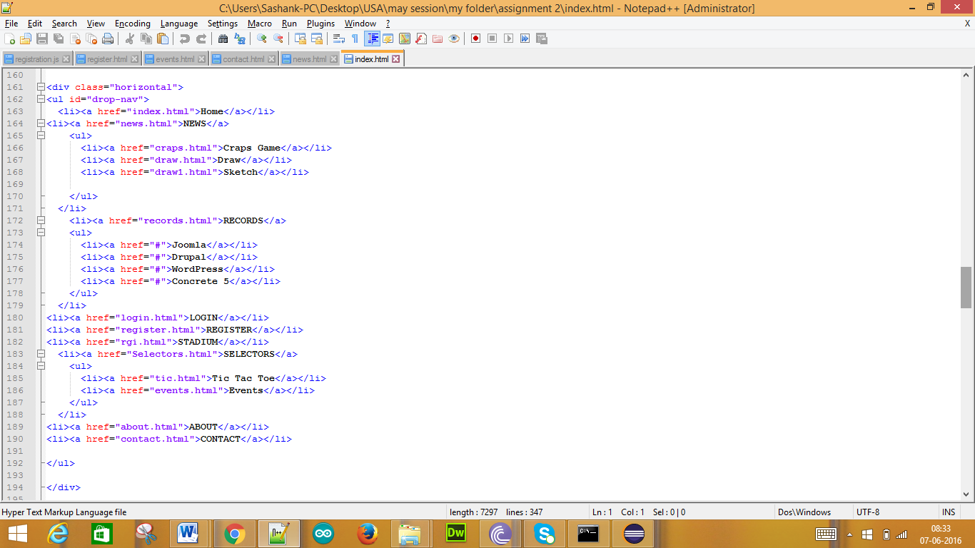

Output:

News drop down list

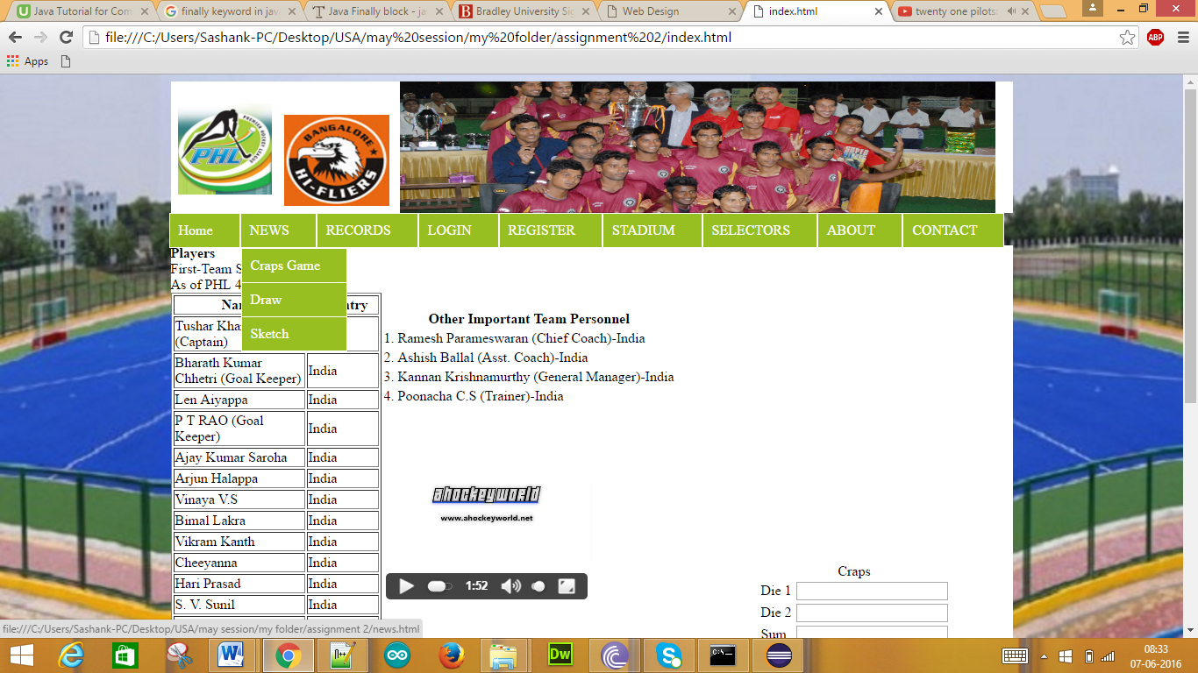

Register drop down list:

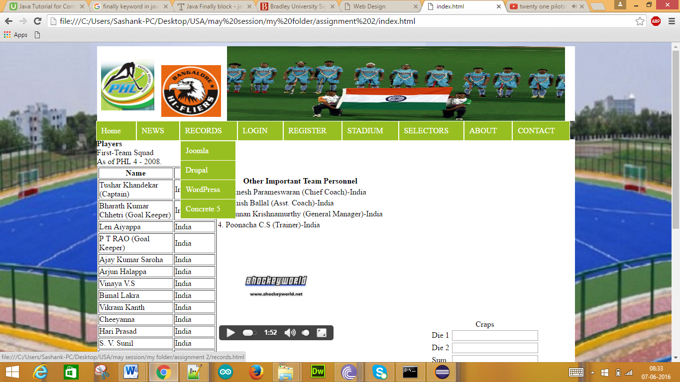

Selectors drop down list:

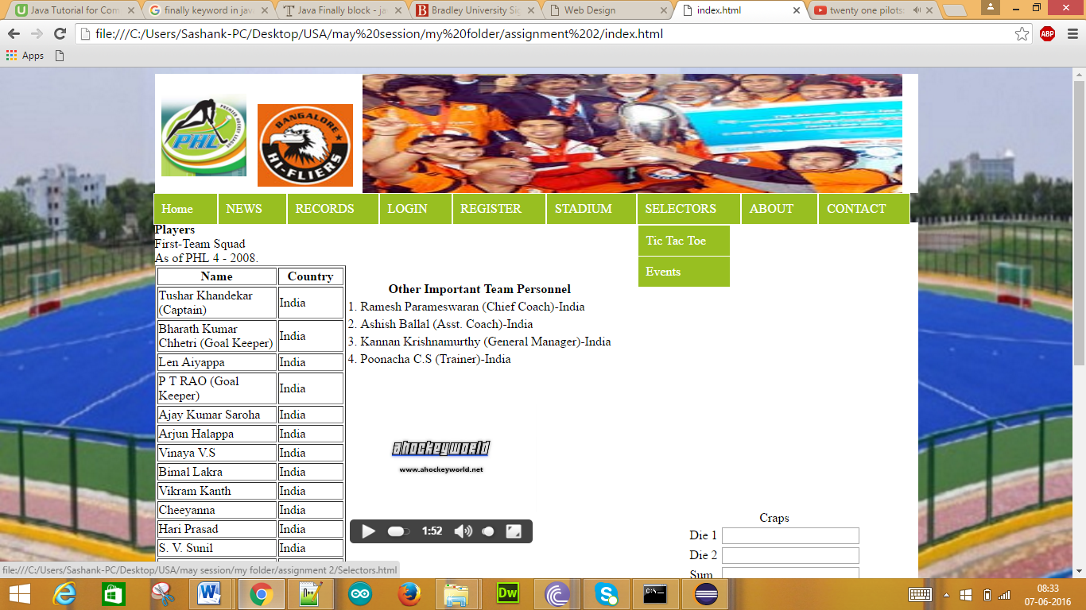

2. Slide Show

Code:

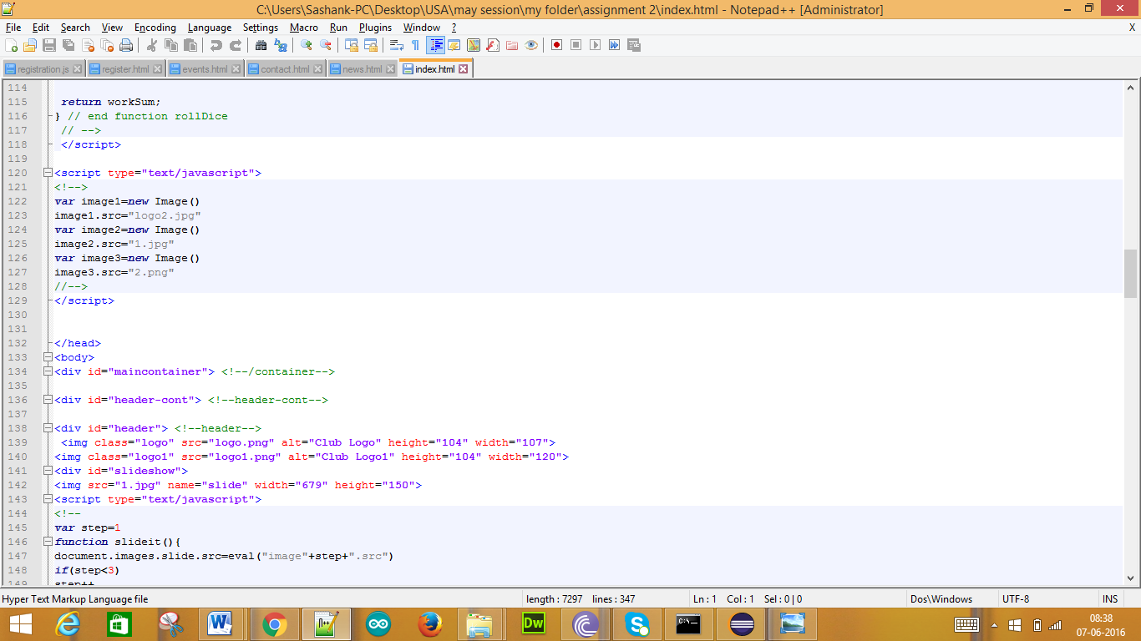

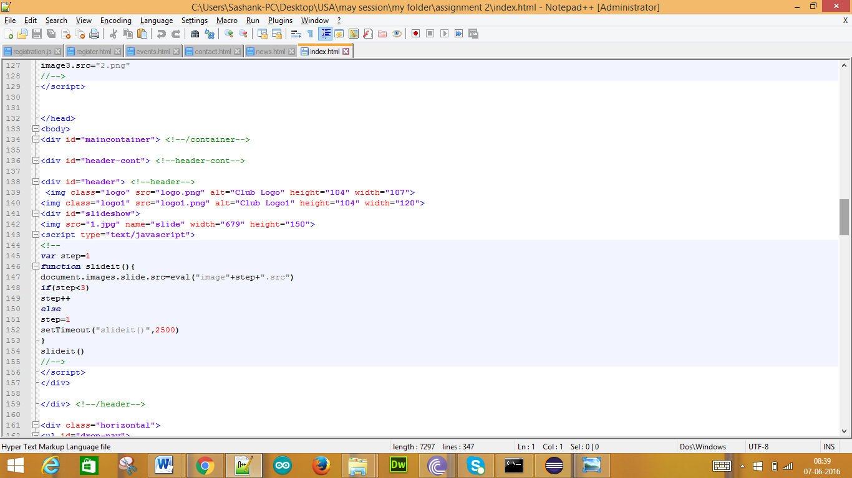

Output:

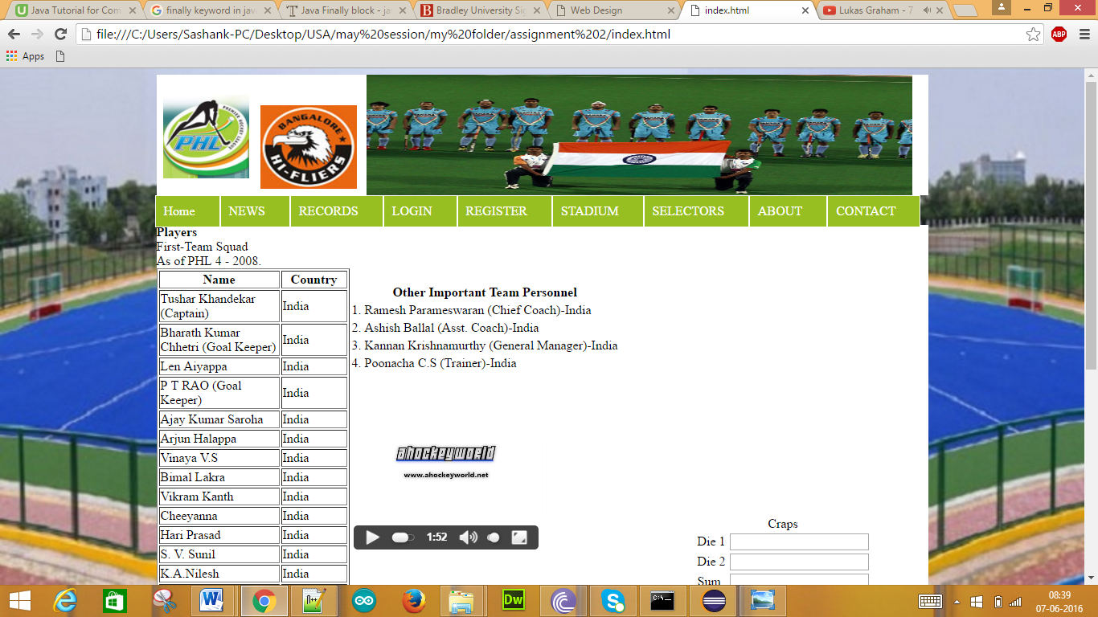

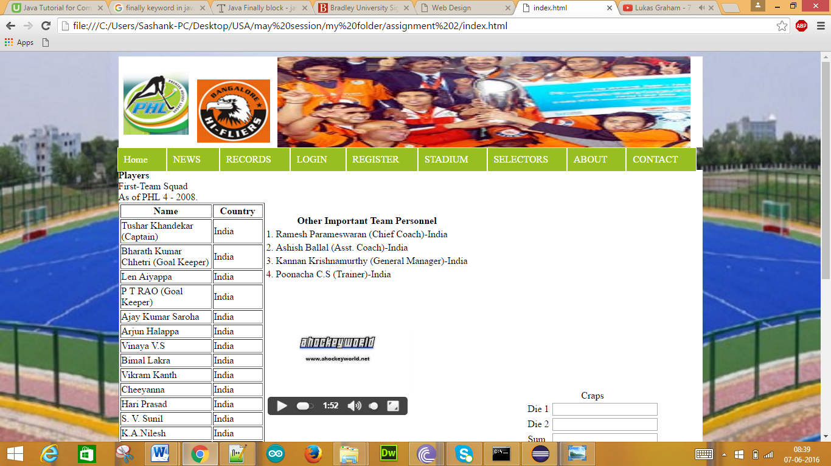

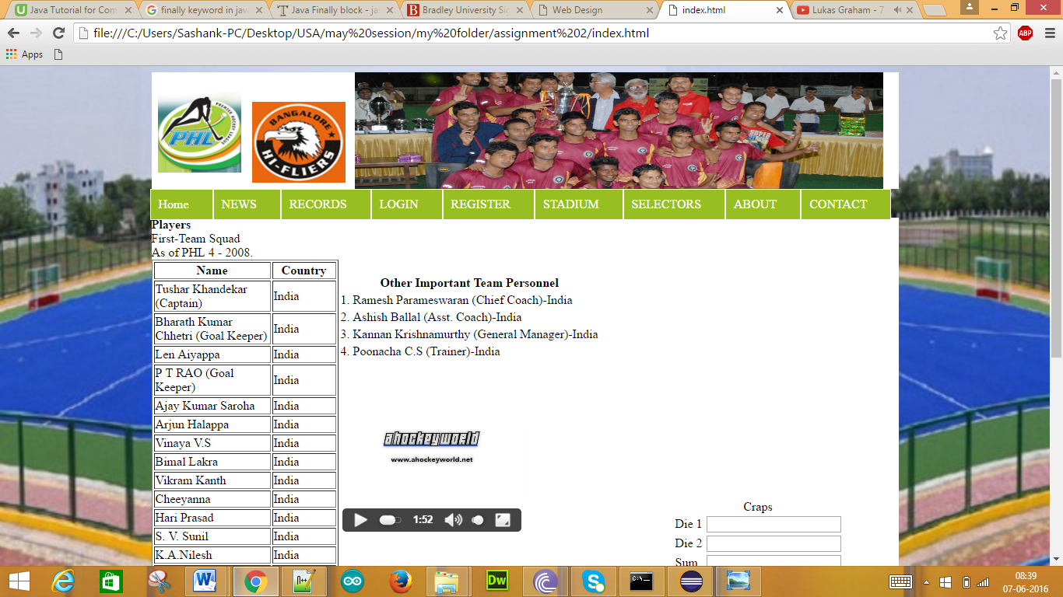

3. Game

Craps Game:

Code:

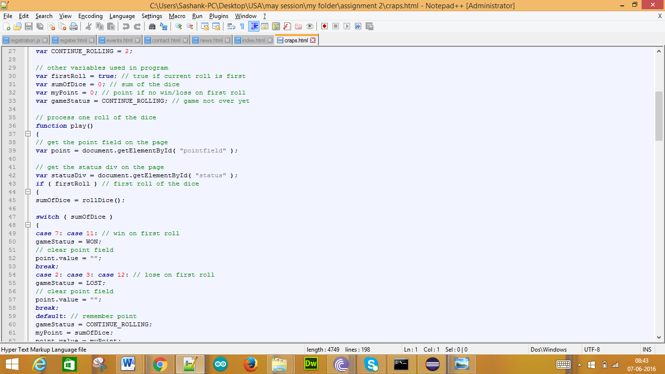

Output:

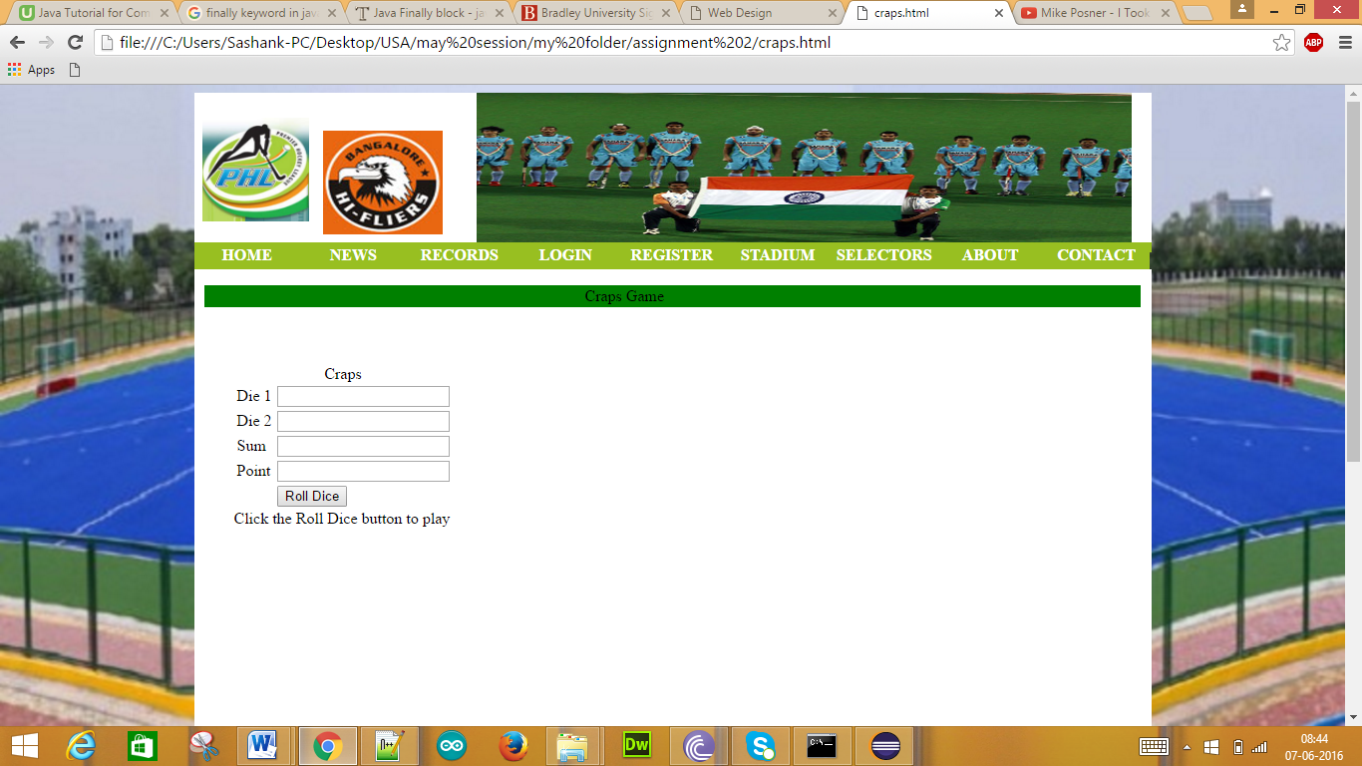

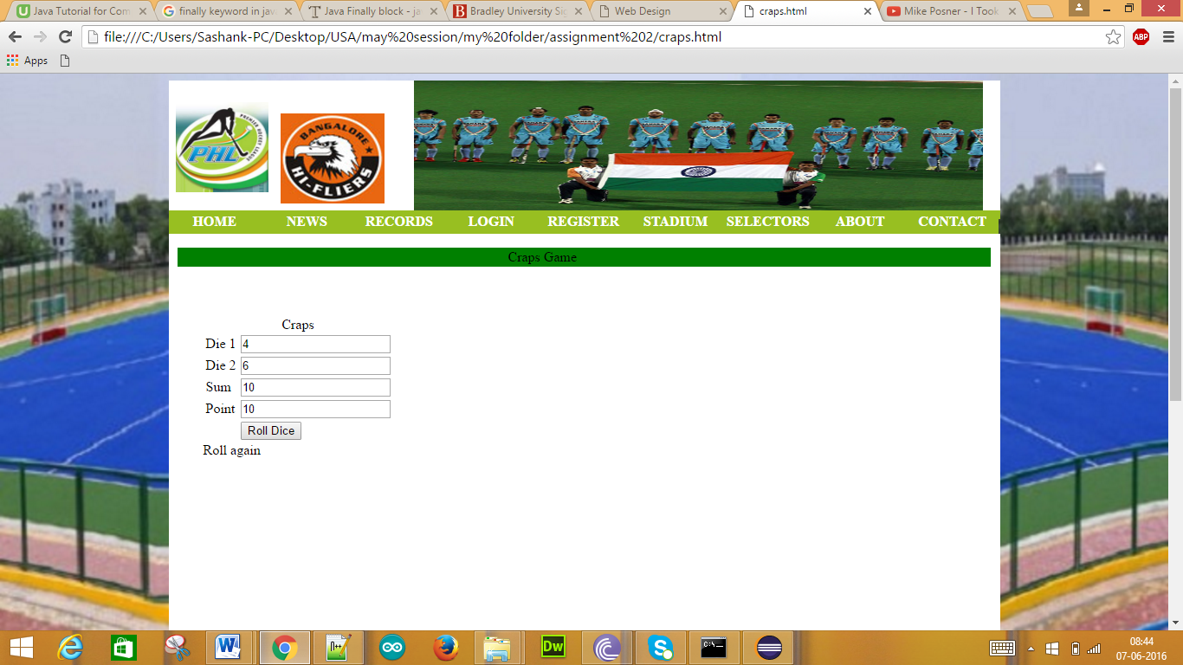

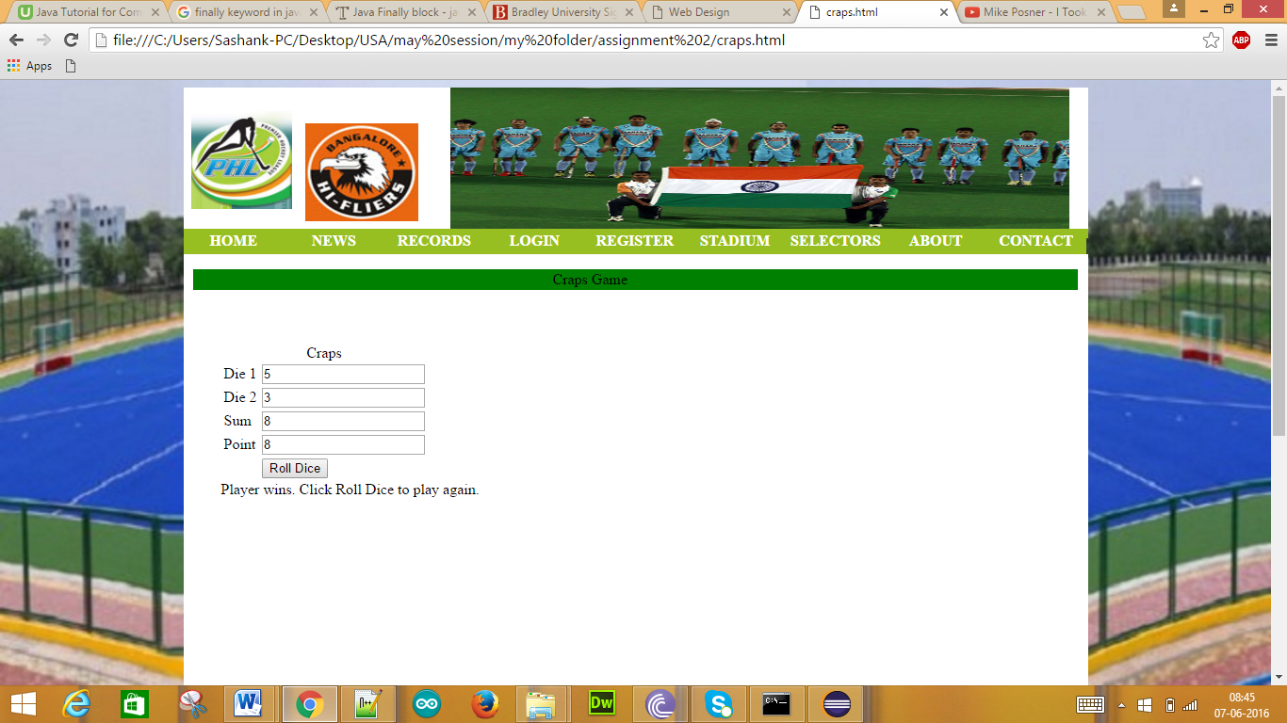

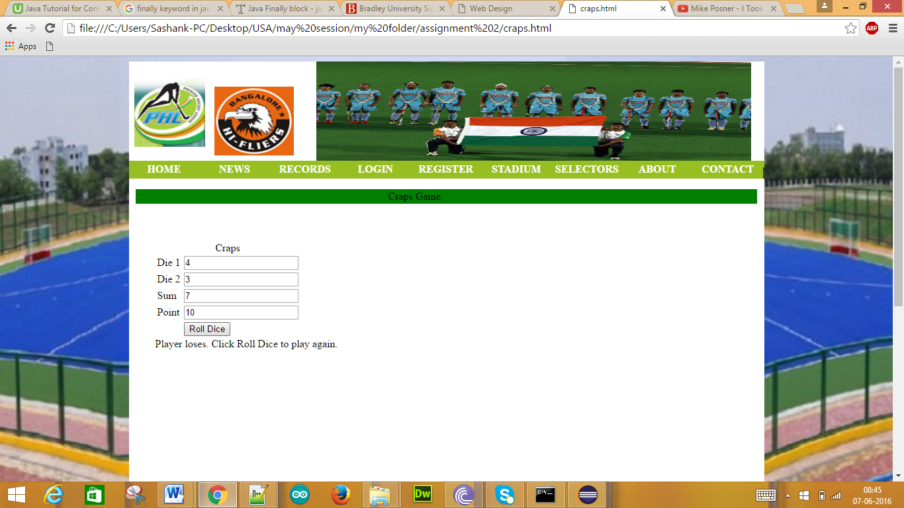

4. Tic Tac Toe Game

Code:

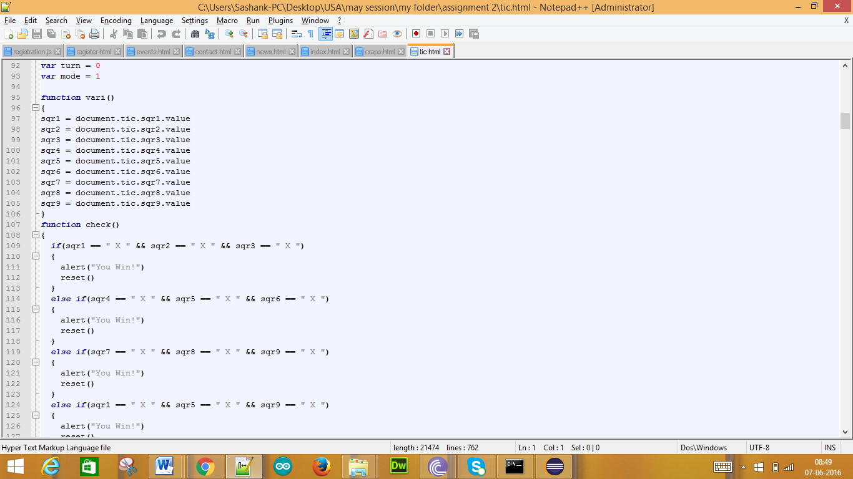

Output:

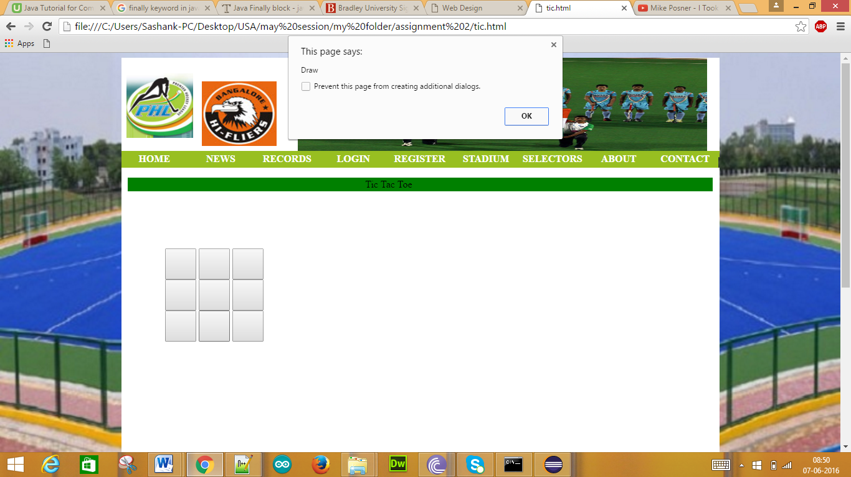

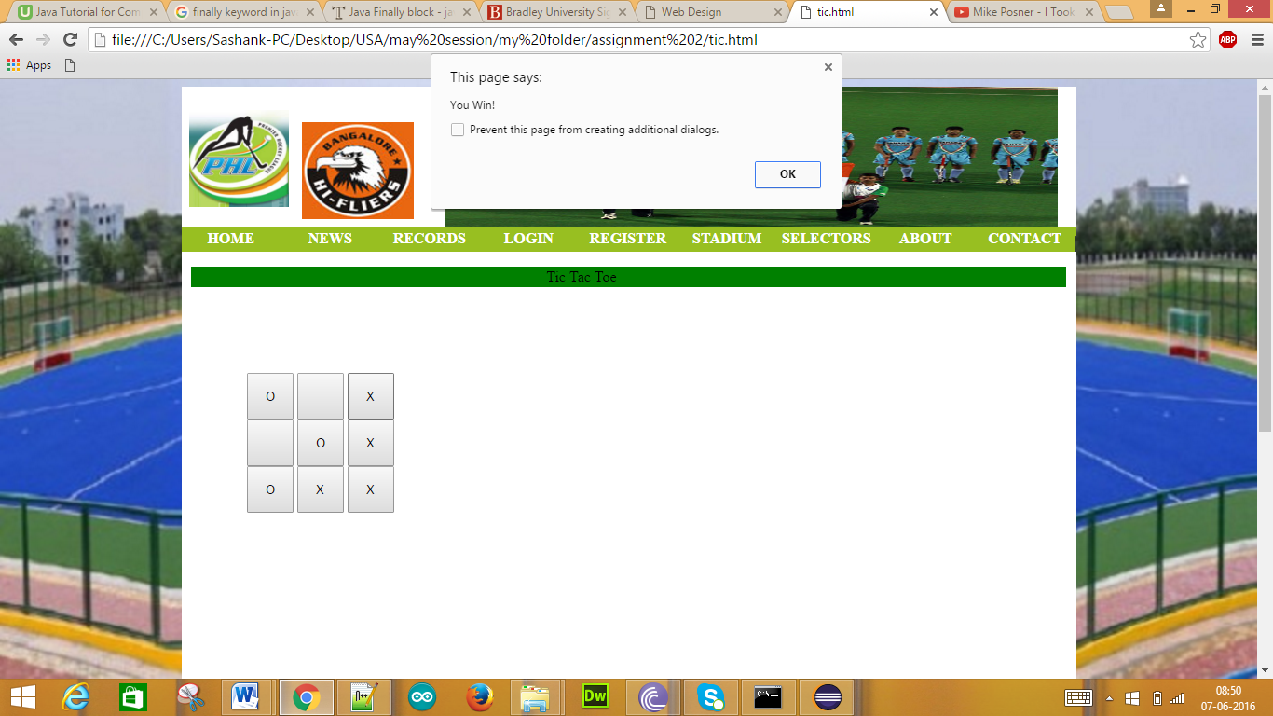

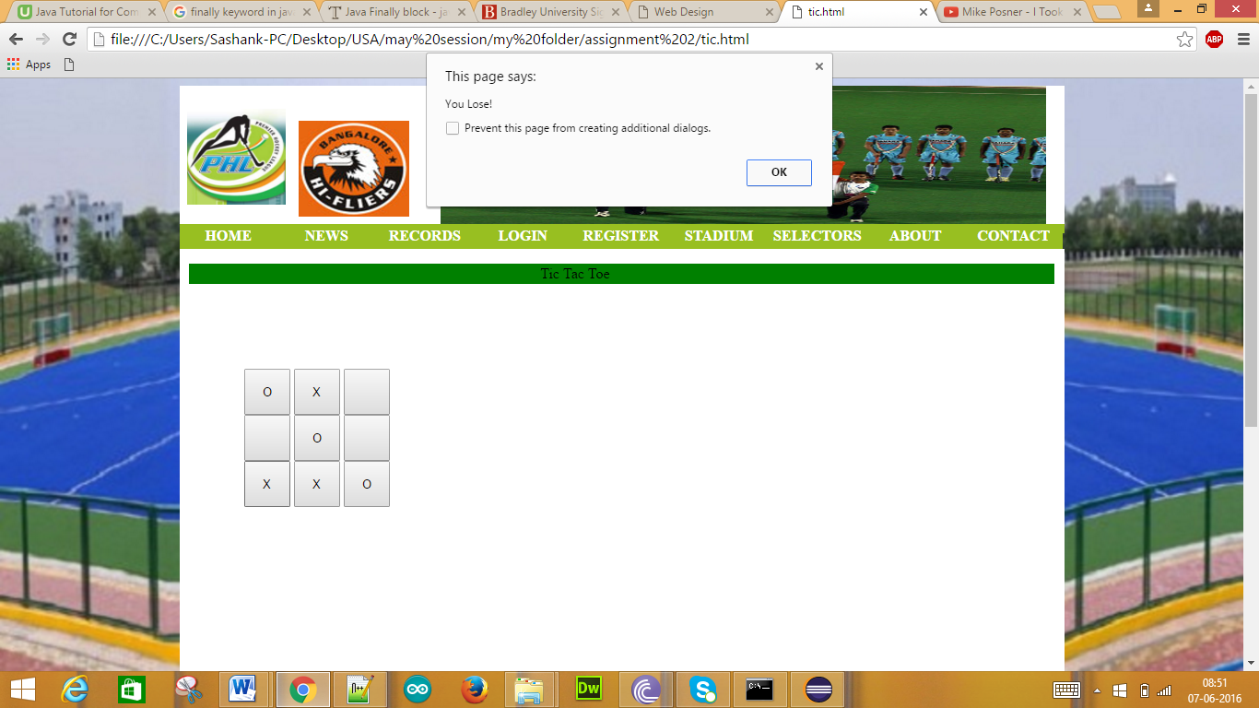

Draw Program

Code:

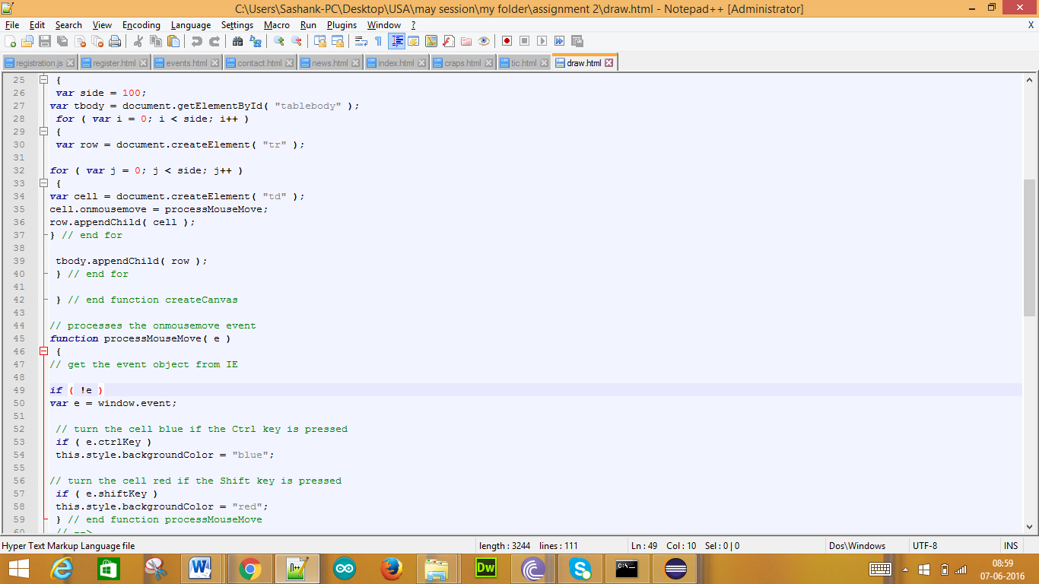

Output:

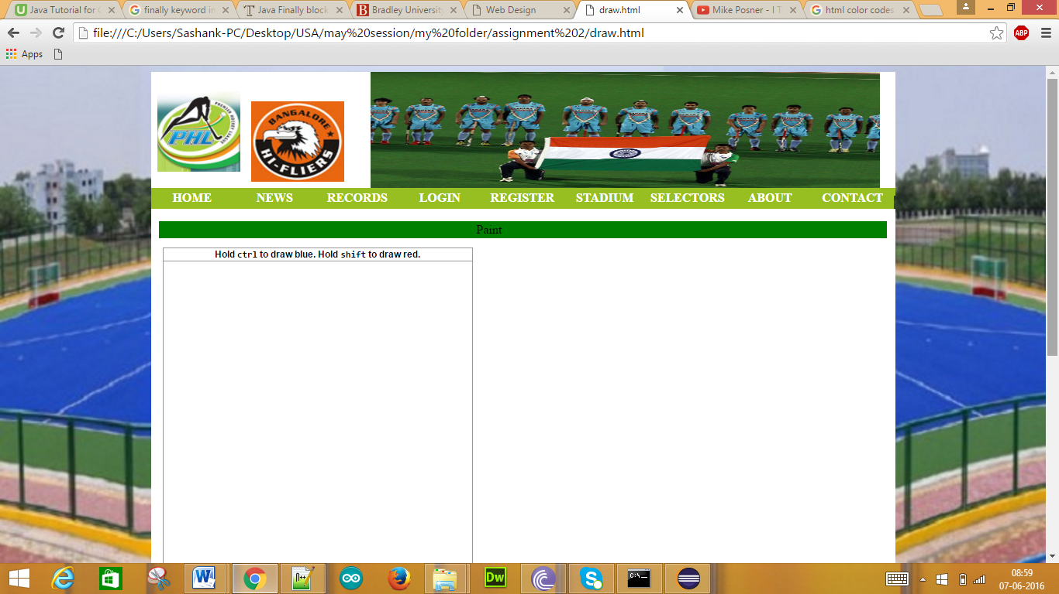

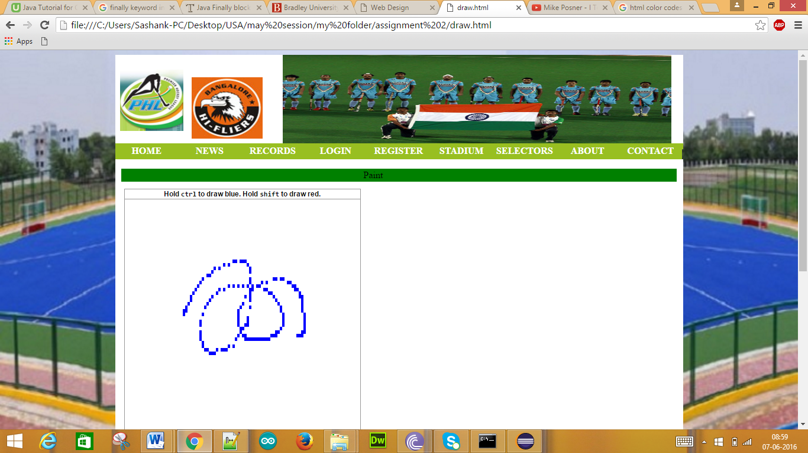

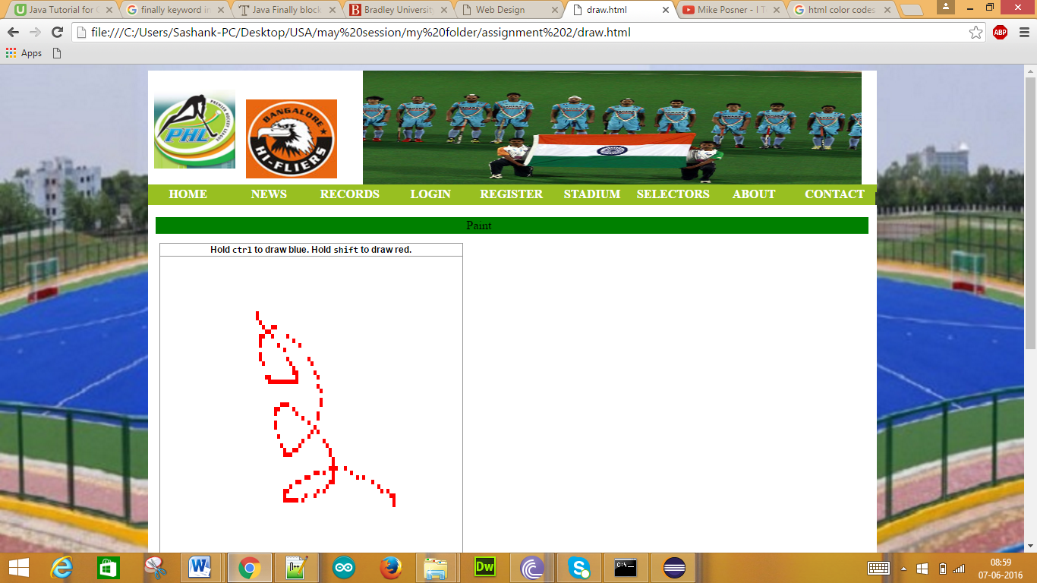

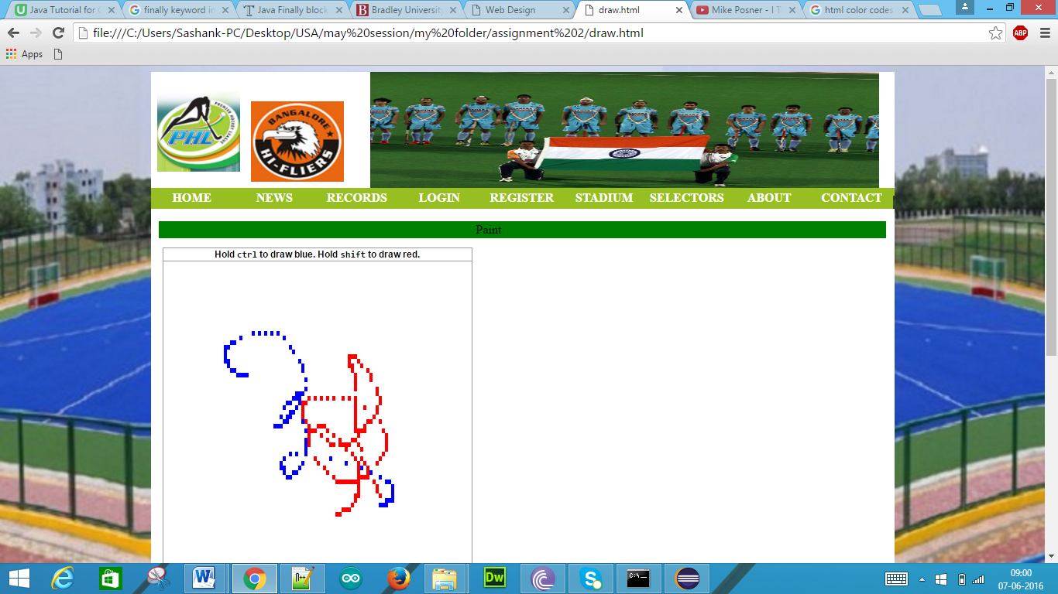

**Additional Dynamic HTML Application:**

Sketch

Code:

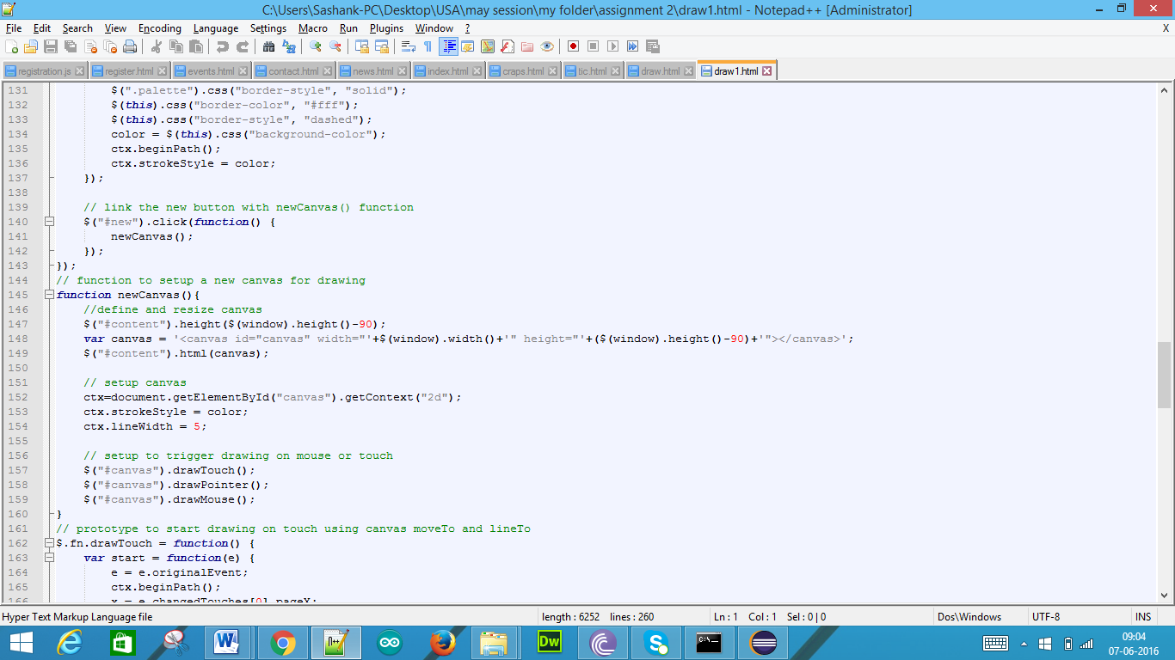

Output:

